

**CC4058 Introduction to Information Systems**

**60% Group Coursework**

**2022-23 Autumn**

| **Group Name: Team1** | | | |
| --- | --- | --- | --- |
| **SN** | **Student Name** | **College ID** | **University ID** |
|  | **Nayan Raj Sah** | **NP01NT4A20034** | **22067077** |
|  | **Arbin Rajbanshi** | **NP01NT4A220016** | **22067054** |
|  | **Mohammad Nurullah** | **NP01NT4A22019** | **22067059** |

**Assignment Due Date: Friday, February 3, 2023**

**Assignment Submission Date: Friday, February 3, 2023**

**Word Count: 242**

**Project File Links:**

| **Google Drive Link:** | Keep Google Drive URL of your Project Here with Anyone in Organization can View Option Enabled |
| --- | --- |

*I confirm that I understand my coursework needs to be submitted online via MySecondTeacher under the relevant module page before the deadline in order for my assignment to be accepted and marked. I am fully aware that late submissions will be treated as non-submission and a mark of zero will be awarded.*

Table of Contents

***1.*** ***Introduction 1***

**1.1** **HTML 2**

**1.2** **CSS 2**

**1.3** **JavaScript 3**

**1.4** **Goals and Objective 3**

***2.*** ***Tools Used 4***

**2.1** **VS code 4**

**2.2** **Draw.io 5**

**2.3** **Google Chrome 5**

**2.4** **MS word 5**

***3.*** ***Wireframe and Webpages 6***

***4.*** ***Testing 7***

**4.1** **Testing: the add to cart JavaScript 7**

**4.2** **Testing: Form validation. 8**

**4.3** **Testing: Typewriter JavaScript 10**

**4.4** **Testing: Hover effect on navigation bar. 12**

**4.5** **Testing: Internal and External links 13**

Table of Figure

Figure 1 : HTML [2](https://docs.google.com/document/d/1low9BdZHEjhYir9sgXOuswrgtVV87NLr/edit#heading=h.2xcytpi)

Figure 2 : CSS [2](https://docs.google.com/document/d/1low9BdZHEjhYir9sgXOuswrgtVV87NLr/edit#heading=h.1ci93xb)

Figure 3 : JavaScript [3](https://docs.google.com/document/d/1low9BdZHEjhYir9sgXOuswrgtVV87NLr/edit#heading=h.3whwml4)

Figure 4 : VS code [4](https://docs.google.com/document/d/1low9BdZHEjhYir9sgXOuswrgtVV87NLr/edit#heading=h.2bn6wsx)

Figure 5 : Draw.io [5](https://docs.google.com/document/d/1low9BdZHEjhYir9sgXOuswrgtVV87NLr/edit#heading=h.qsh70q)

Figure 6 : Google chrome [5](https://docs.google.com/document/d/1low9BdZHEjhYir9sgXOuswrgtVV87NLr/edit#heading=h.3as4poj)

Figure 7 : Ms word [5](https://docs.google.com/document/d/1low9BdZHEjhYir9sgXOuswrgtVV87NLr/edit#heading=h.1pxezwc)

Figure 8 : Before testing add to cart JavaScript [7](https://docs.google.com/document/d/1low9BdZHEjhYir9sgXOuswrgtVV87NLr/edit#heading=h.49x2ik5)

Figure 9 : After testing add to cart JavaScript [8](https://docs.google.com/document/d/1low9BdZHEjhYir9sgXOuswrgtVV87NLr/edit#heading=h.2p2csry)

Figure 10 : submit with filling form [9](https://docs.google.com/document/d/1low9BdZHEjhYir9sgXOuswrgtVV87NLr/edit#heading=h.147n2zr)

Figure 11 : submit without filling form. [9](https://docs.google.com/document/d/1low9BdZHEjhYir9sgXOuswrgtVV87NLr/edit#heading=h.3o7alnk)

Figure 12 : Typewriter JavaScript with Plantkingdom text. [10](https://docs.google.com/document/d/1low9BdZHEjhYir9sgXOuswrgtVV87NLr/edit#heading=h.23ckvvd)

Figure 13 : Typewriter JavaScript with Indoor Bonsai text. [11](https://docs.google.com/document/d/1low9BdZHEjhYir9sgXOuswrgtVV87NLr/edit#heading=h.ihv636)

Figure 14 : Figure 13 : Typewriter JavaScript with Outdoor Bonsai text. [11](https://docs.google.com/document/d/1low9BdZHEjhYir9sgXOuswrgtVV87NLr/edit#heading=h.32hioqz)

Figure 15 : Before testing hover. [12](https://docs.google.com/document/d/1low9BdZHEjhYir9sgXOuswrgtVV87NLr/edit#heading=h.1hmsyys)

Figure 16 : After testing hover. [12](https://docs.google.com/document/d/1low9BdZHEjhYir9sgXOuswrgtVV87NLr/edit#heading=h.41mghml)

Figure 17 : Scroll to About us section [13](https://docs.google.com/document/d/1low9BdZHEjhYir9sgXOuswrgtVV87NLr/edit#heading=h.2grqrue)

Figure 18 : showing internal link. [14](https://docs.google.com/document/d/1low9BdZHEjhYir9sgXOuswrgtVV87NLr/edit#heading=h.vx1227)

Figure 19 : showing external link. [14](https://docs.google.com/document/d/1low9BdZHEjhYir9sgXOuswrgtVV87NLr/edit#heading=h.3fwokq0)

Table of table

Table 1 : Testing the add to cart JavaScript 7

Table 2 : Testing Form validation 8

Table 3 : testing typewriter JavaScript 10

Table 4 : Testing hover effect on navigation bar. 12

Table 5 : Testing: Internal and External links. 13

# **Introduction**

This is a group coursework of module Introduction to information system which is about creating an E-commerce website with at least 5 web pages including Home page, Blog page, Product page, Research page, and About Us page. In blog page, we need to explain what the impacts of technology in our daily lives and business.

A five-page E-commerce website that has Home, Plants, Research, Blog, and About Us has been developed by our team. The home page greets visitors and guides them to other pages as desired. On the plants page, you can buy some of our plants right away or add them to your shopping cart. All of our website and teammate information can be found on the "about us" page. We discussed the effects of internet technology on daily life and business on the blog page. Finally, the study I conducted to create our e-commerce website is included on the research page.

PlantKingdom is an online distributor or retailer of several bonsai plant kinds as well as other numerous different sorts of plants. The plants store is a virtual one with sellers all around Nepal. The online plant store is open 24 hours a day, six days a week (Monday through Friday), and delivery can take 2 to 5 days, depending on the circumstance.

Let's learn more about HTML, CSS, and JavaScript since they are the foundation of this coursework:

## **HTML**



Hyper Text Markup Language, or HTML. It is a common markup language used to create web pages. Using HTML components, such as tags and attributes, it enables the development and structuring of sections, paragraphs, and links. Noting that HTML lacks the ability to build dynamic functionality, it should be noted that it is not regarded as a programming language. It is now accepted as a web standard. HTML specifications are updated frequently and are developed and maintained by the World Wide Web Consortium (W3C) (hostinger, n.d.).

## **CSS**

Cascading Style Sheets (CSS) is a stylesheet language used to describe how a document written in HTML or XML is presented (including XML dialects such as SVG, MathML or XHTML). CSS specifies how items should be shown on screens, in print, during speech, or in other media. According to W3C guidelines, CSS is one of the fundamental languages of the open web and is standardized across all Web browsers. Previously, the development of different components of the CSS specification was carried out synchronously, allowing for the versioning of the most recent recommendations. You may be familiar with CSS1, CSS2.1, or perhaps CSS3. There won't ever be a CSS3 or CSS4; instead, everything is now CSS without a version number (developer.mozilla, n.d.).

## **JavaScript**



Most of modern online browsers use JavaScript as their primary scripting language, but its early oddities garnered it a bad rap. The language has improved and changed through time, nevertheless. Now used for more complicated web development and beyond, JavaScript is a strong, adaptable, and quick programming language. Since JavaScript continues to be the foundation of web development, it's frequently the first language self-taught coders eager to study and create acquire. With the JavaScript foundation you acquire here, we're eager to see what you can design. Most of websites, including this one, rely on JavaScript to fuel their dynamic functionality (codecademy, n.d.).

## **Goals and Objective**

The goal of this project is to build an "E-commerce" website. Here, each of us is required to develop a website of our own design with at least five web pages, including those for blogs, products, blogs, research, and about us. The focus of blogs is the influence of technology in the modern world, and the research page lists all the websites that were used for both research and assistance. Technologies like HTML5, CSS, and JavaScript are employed to construct this E-commerce. It is recommended to employ HTML tags like Div, Table, Form, IMG, Meta, and others. It is also recommended to use CSS of all types, including internal, inline, and external. JavaScript was used for form dynamically change the content of the website and do other tasks such as form validation.

The project's goals and objectives are to show how well students comprehend the fundamentals of internet technology as well as its effects on or changes to daily life. Through this project, the students' creativity is evaluated together with their knowledge of HTML5, CSS, and JavaScript. It also identifies their level of proficiency in these languages. With their understanding of how to utilize these technologies, the objective of this project is to prepare them to create their own websites.

# **Tools Used**

To develop the website, we need various tools and technologies. HTML, CSS, and JavaScript played major role in the process. Beside them Draw.io, VS code, Google Chrome etc were also used for the completion of this coursework.

## **VS code**



On your desktop and the web, Visual Studio Code is a free, compact yet capable source code editor that operates on Windows, macOS, Linux, and Raspberry Pi OS. It is also available for other operating systems. It features built-in support for JavaScript, TypeScript, and Node.js and a robust community of extensions for additional programming languages (including C++, C#, Java, Python, PHP, and Go), runtimes (like.NET and Unity), environments (like Docker and Kubernetes), clouds, and other environments (such as Amazon Web Services, Microsoft Azure, and Google Cloud Platform).

In addition to the general idea of being lightweight and starting quickly, Visual Studio Code has built-in source code control, including Git support, linting, multi-cursor editing, parameter hints, and other powerful editing features. It also has IntelliSense code completion for variables, methods, and imported modules. This was mostly modified using Visual Studio technology (Heller, 2022).

## **Draw.io**

Draw.io is a robust, user-friendly, secure diagram generating tool that is fully integrated with Confluence. Additionally, it is completely responsive and offers desktop software capabilities on mobile devices, including touch-specific tools. For your organizational charts, BPMN, UML, ER diagrams, wireframes, mock-ups, network diagrams, flowcharts, and other designs, create your own templates or utilize custom shape libraries. The best part is that none of your private diagram data ever leaves Confluence (globallogic, n.d.).

## **Google Chrome**



The Google Chrome is free web browser can be used to access the internet and operate web-based programs. The open-source Chromium web browser project serves as the foundation for the Google Chrome browser. Google launched Chrome in 2008 and updates it frequently (Barney, n.d.).

## **MS word**



We can produce expert-calibre reports, documents, resumes, and letters using Microsoft Word. Microsoft Word features advantages over plain text editors, such as grammar and spell checking, image support, text and font formatting, complex page layout, HTML compatibility, and more (testbook, n.d.).

# **Wireframe and Webpages**

A wireframe is a two-dimensional representation of a page's interface that focuses on the allocation of content space and priority, available features, and desired actions. For these reasons, style, colour, or images are often absent from wireframes. Additionally, wireframes aid in defining connections across the various website layouts (usability, n.d.).

There are numerous methods to construct the same screen, but only a select handful of them will effectively convey your message and produce software or a website that is simple to use. Developing a strong interface structure is arguably the most crucial aspect of software design.

You will save a ton of time and gruelling adjustment work later if you complete this job now, before any code is written and before the visual design is complete. Read about The Two Phases of Wireframing, watch our in-depth Wireframing for Newbies video, or read the brief description below for additional information on why individuals choose to wireframe (balsamiq, n.d.).

## **Home page**

The primary page of a website for an E-commerce website is the home page. The document has a header, navigations, a body containing graphics and introductions, as well as footers. It will assist in directing viewers to more pages with only one click. And also have overview of all another webpage.

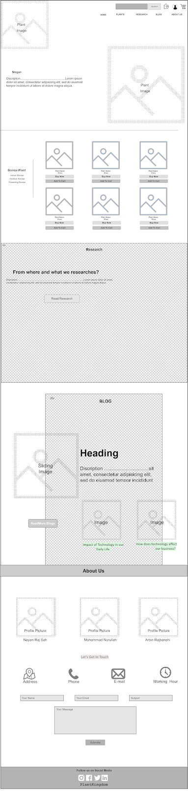



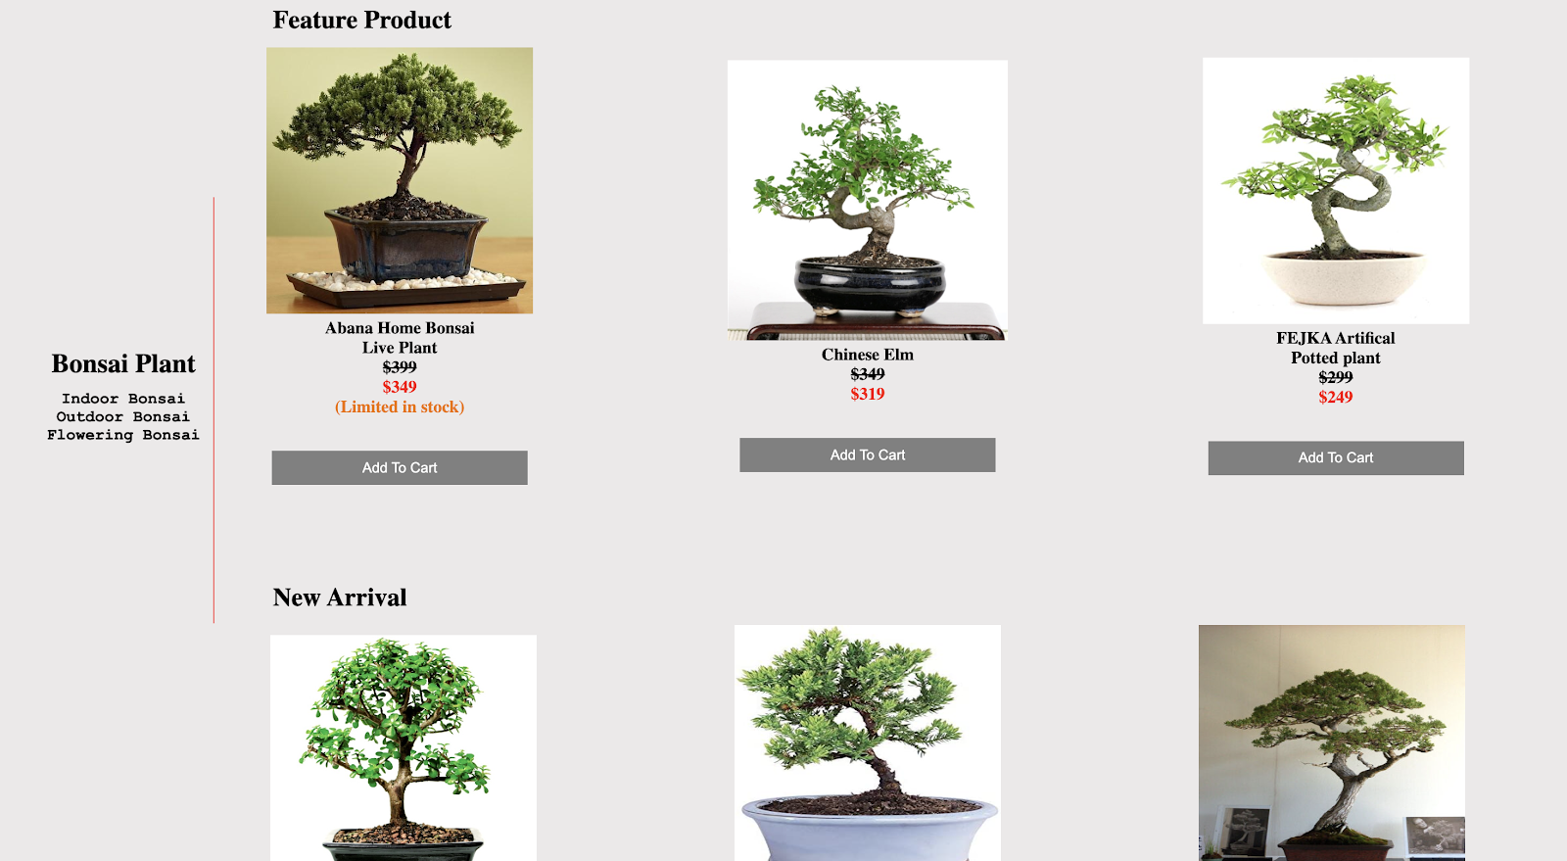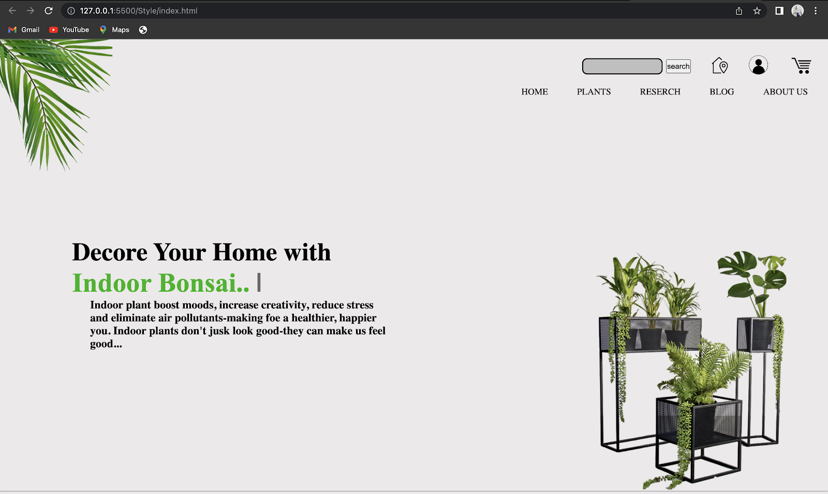

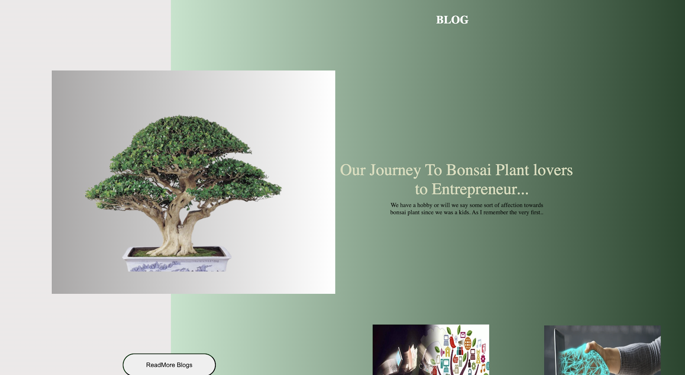

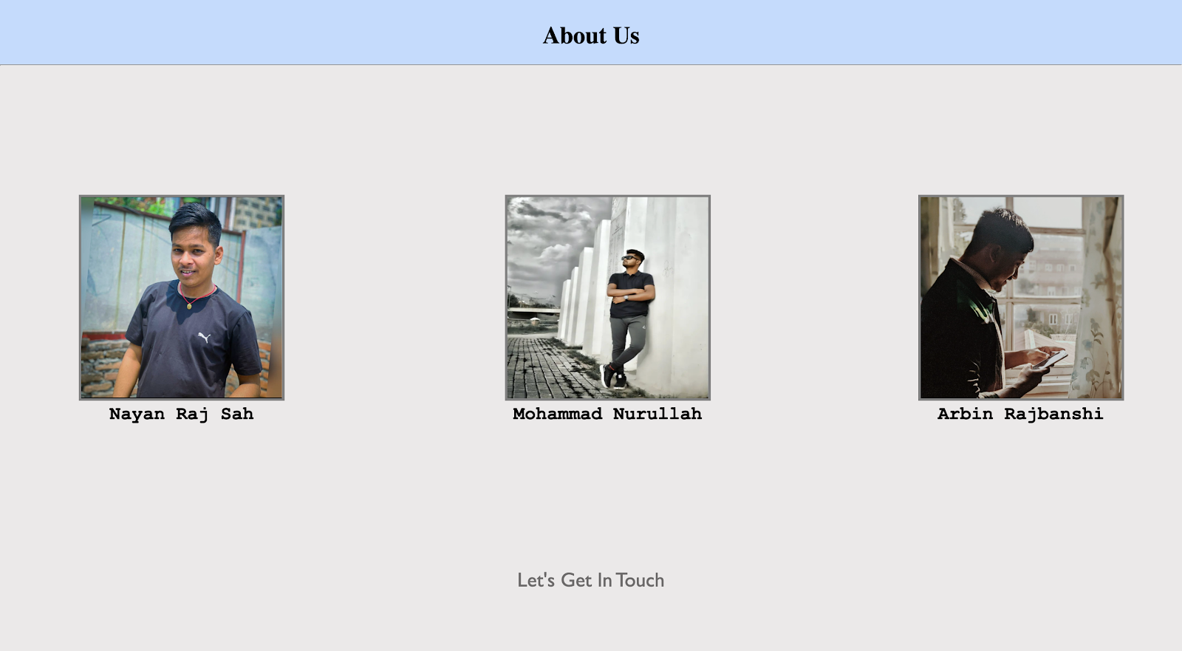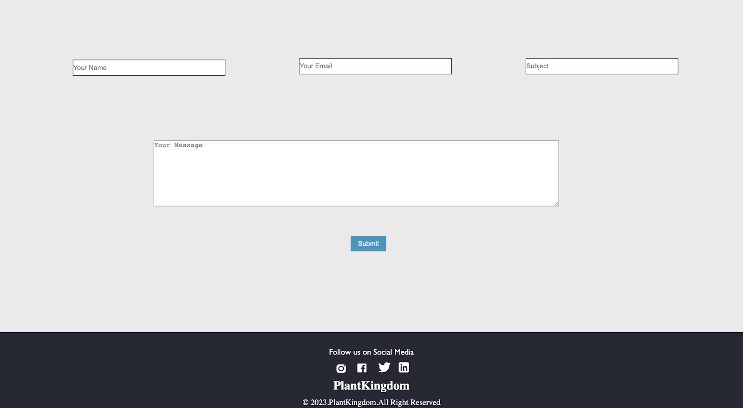

## **Indoor Bonsai**

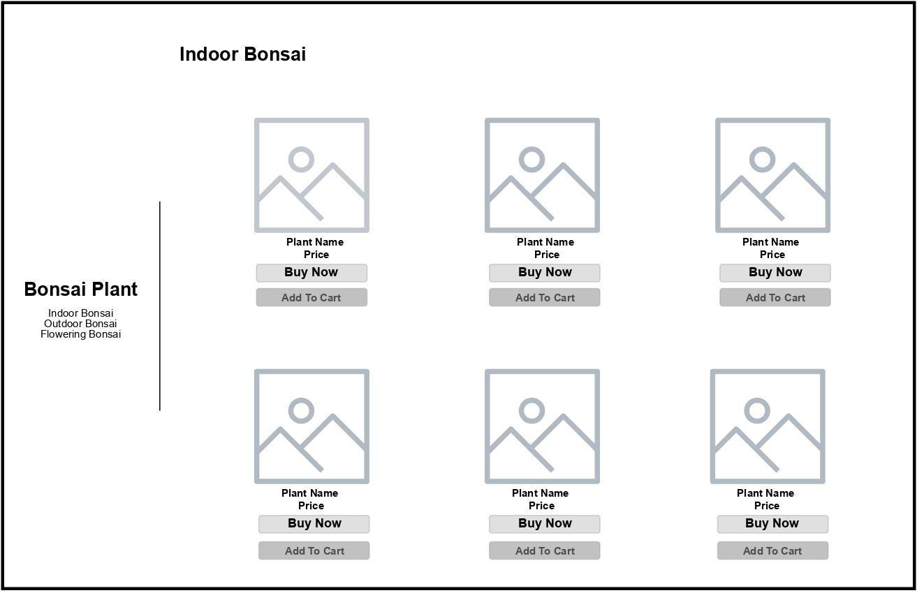

## 

## 

## **Outdoor Bonsai**

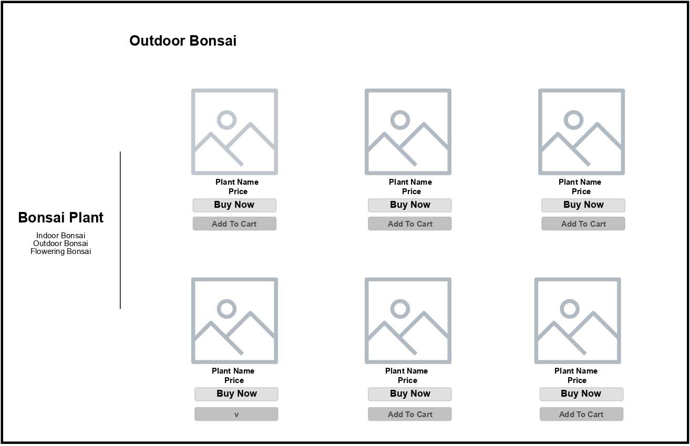

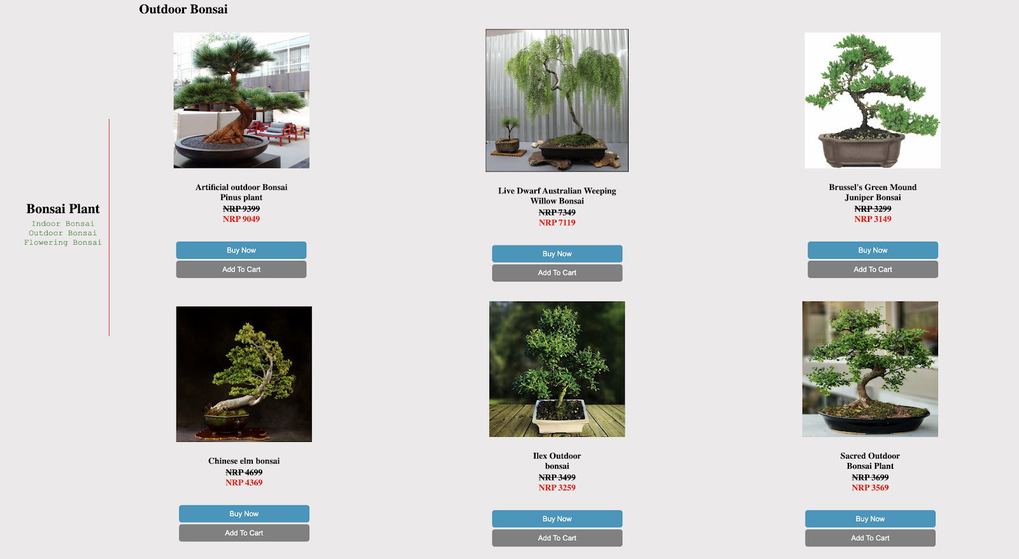

## **Research**

## 

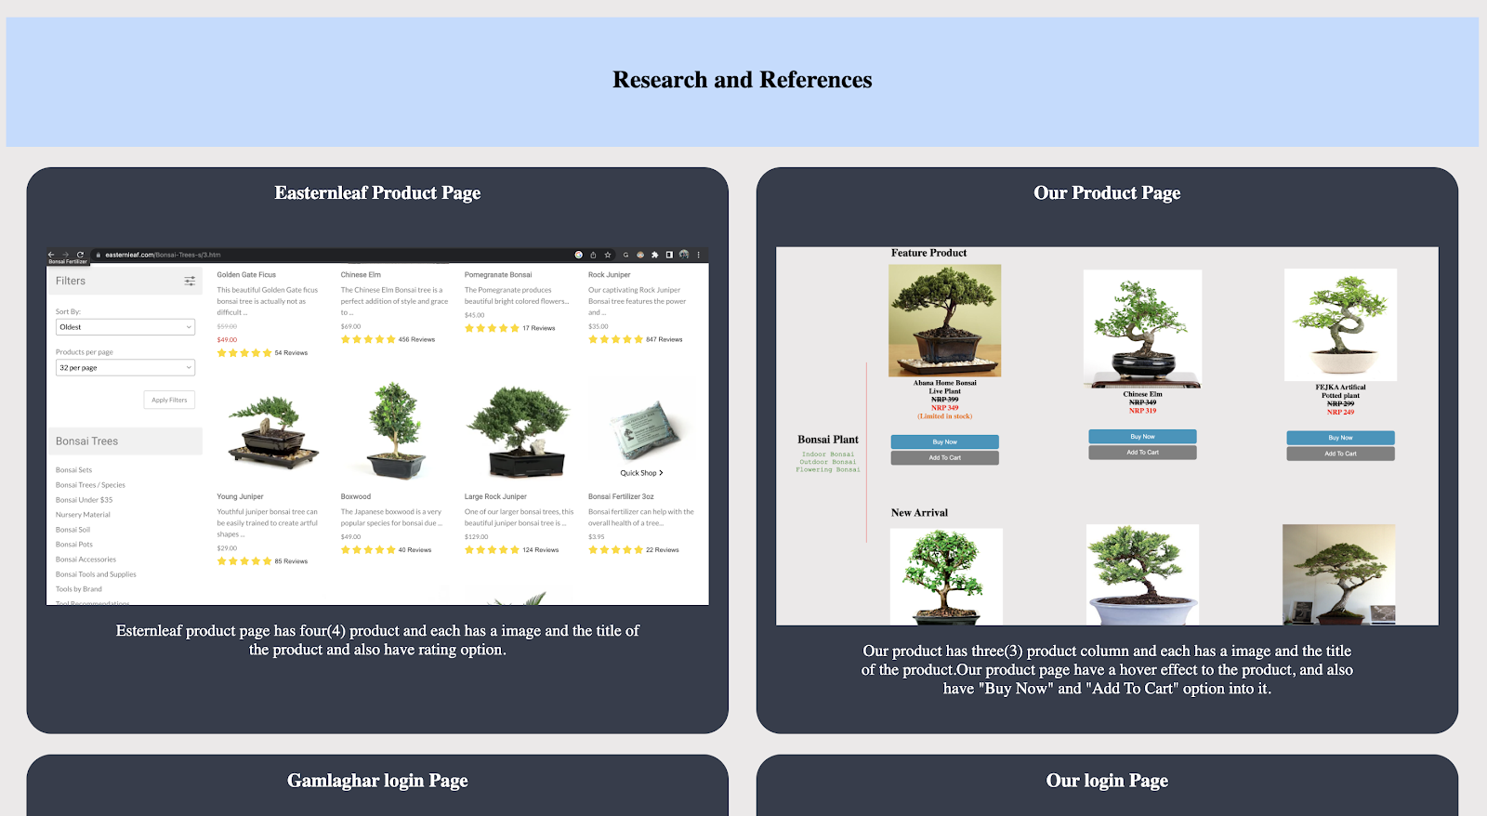

## **Blog page**

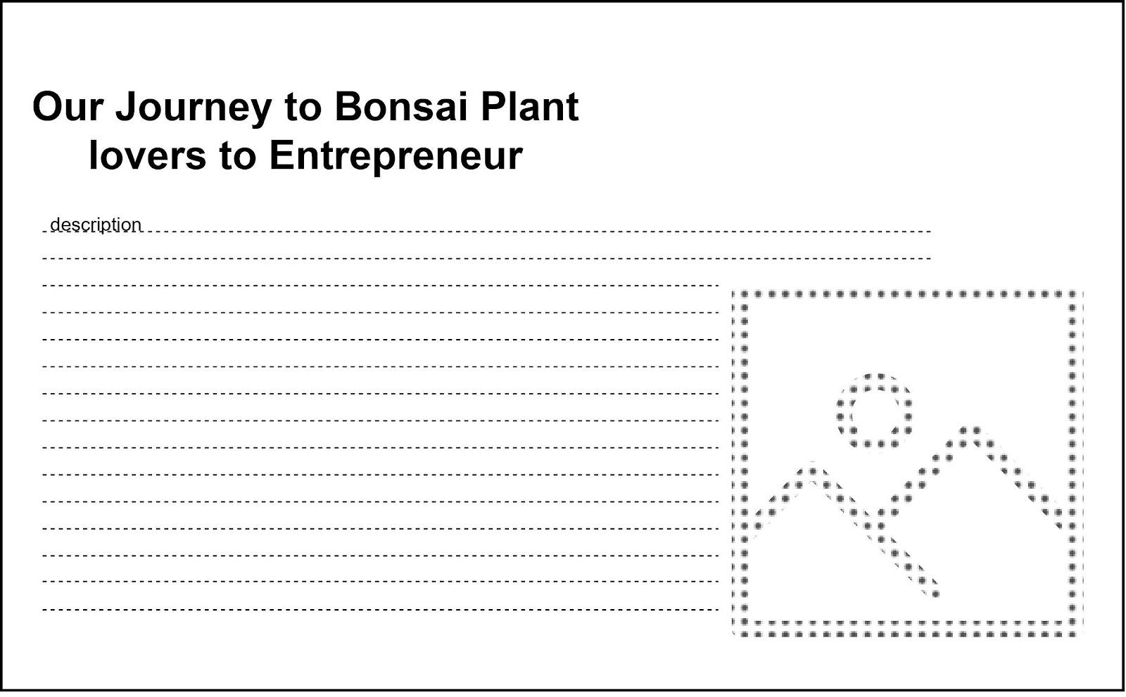

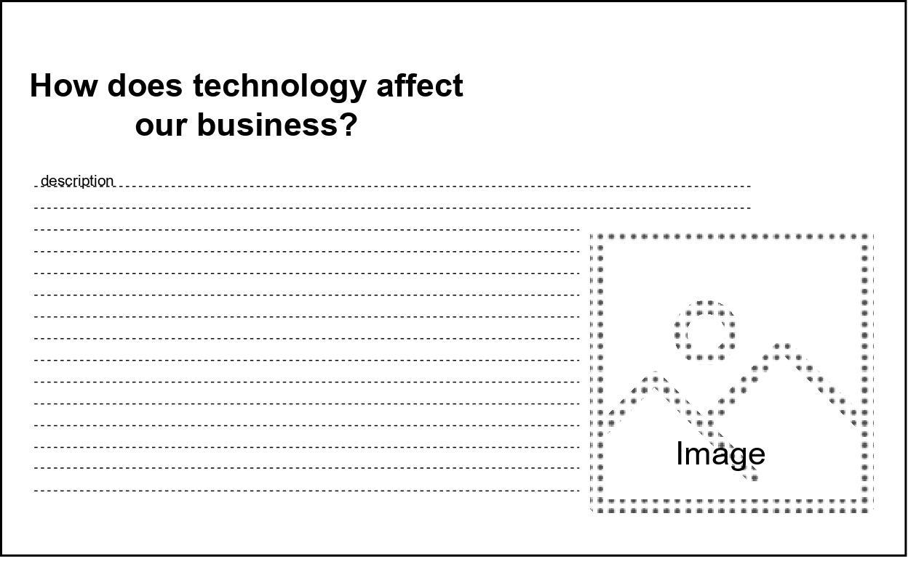

## **Portfolio**

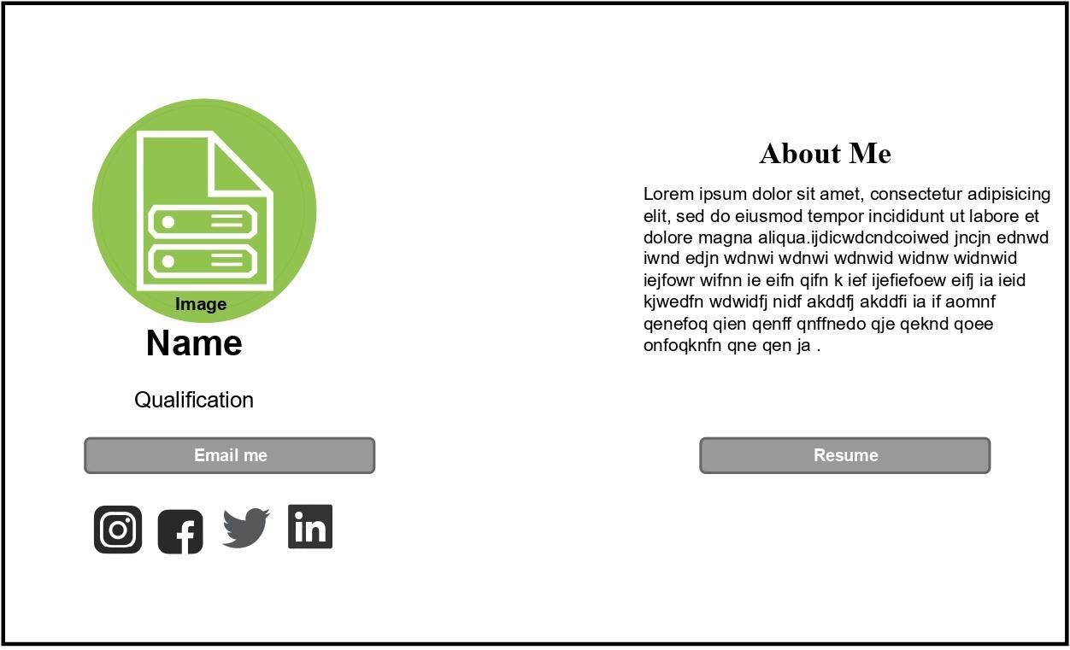

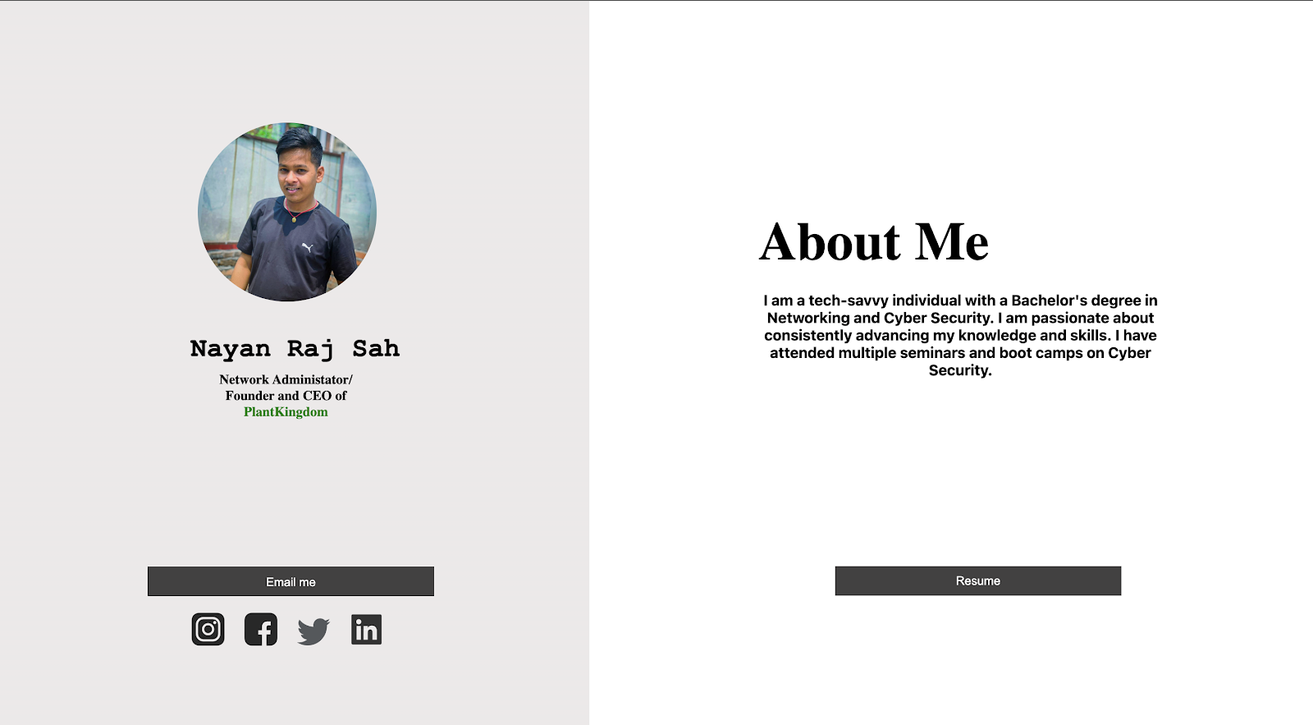

## **Resume**

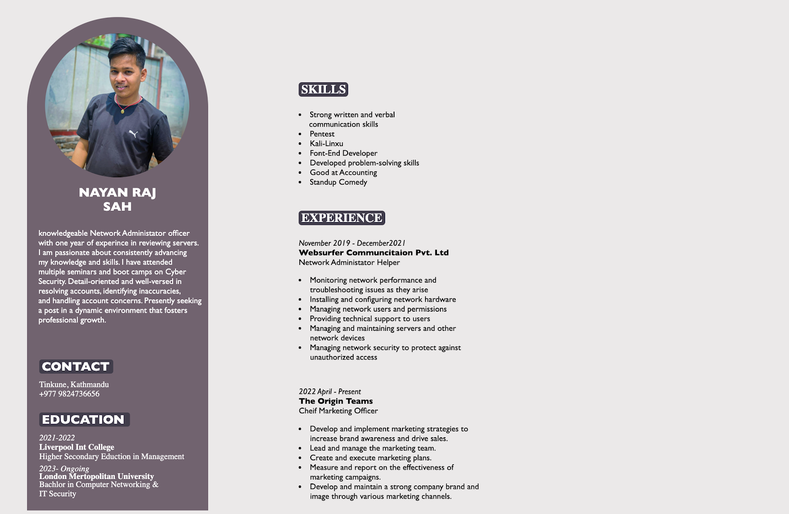

## **Login**

## **Cart**

## 

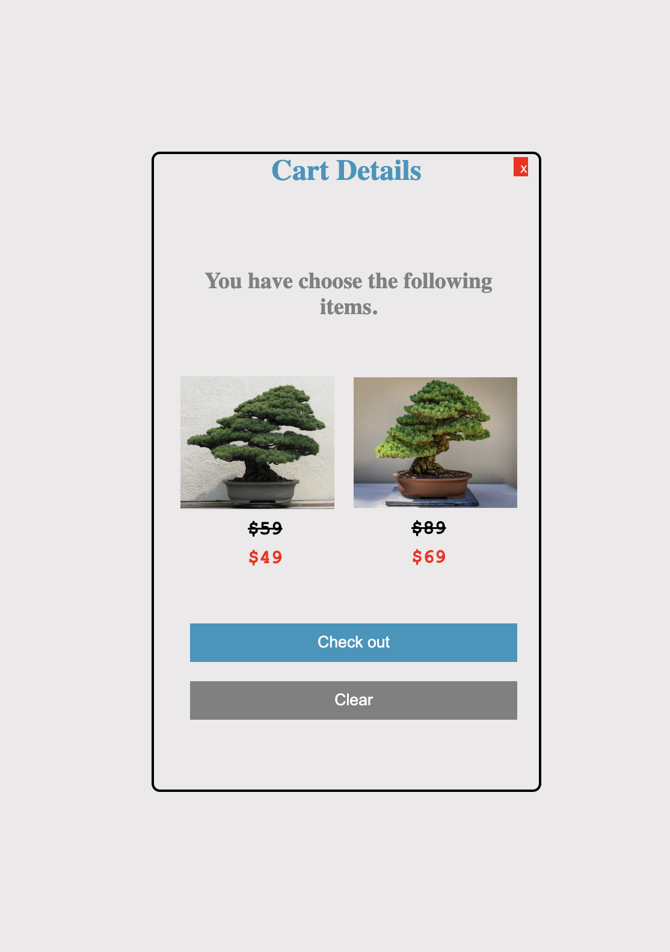

# **Testing**

Before launching a website, it is best to test it out. Its objectives are to increase task confidence and to determine whether there are any errors.

## 

## **Testing: the add to cart JavaScript**

| Test no. | 1 |
| --- | --- |
| Action | Scroll to the plants page.  Click the “Add to cart” button.  See the cart it’s works or not. |
| Expected Output | The number of cart item should be increase. |
| Actual Output | The number of cart item has increase. |
| Conclusion | Test Successful |

*Table 1 : Testing: the add to cart JavaScript*

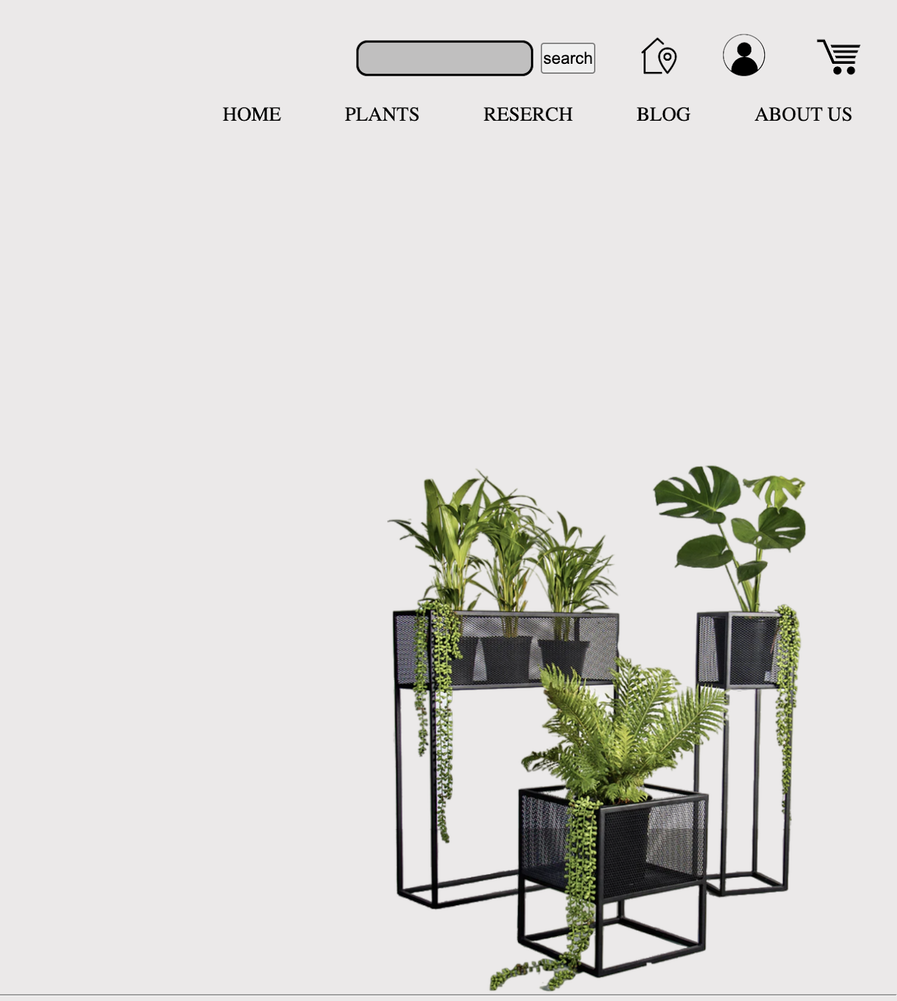



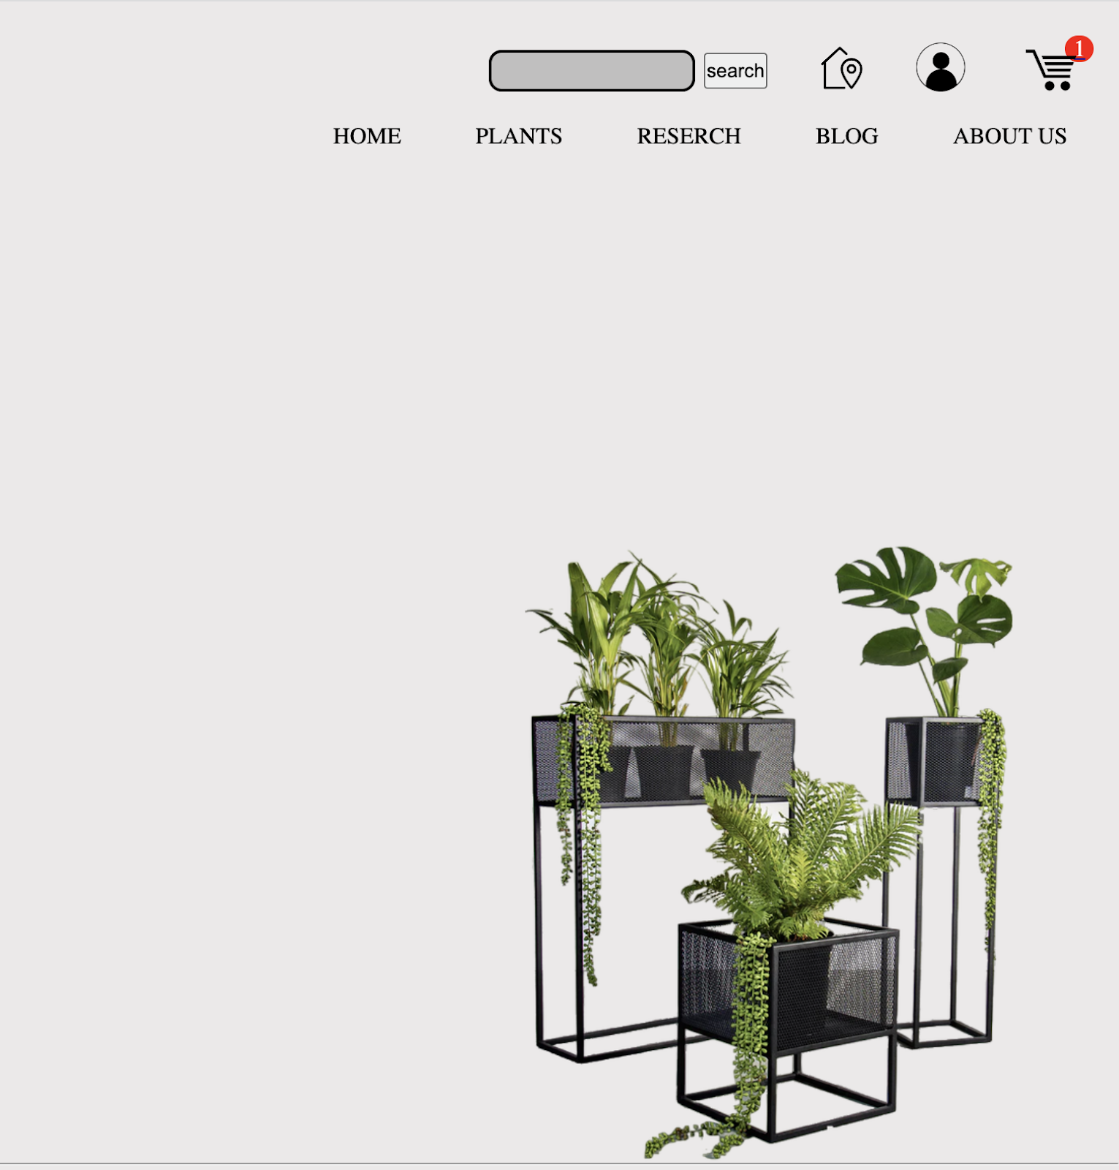



## **Testing: Form validation.**

| Test no. | 2 |
| --- | --- |
| Action | Scroll to the About Us section.  Fill the form and submit it or submit without  filling it.  Show the pop-up on the screen. |
| Expected Output | If your criteria are met or not it show pop-up on the screen. |
| Actual Output | The pop-up on shown on the screen. |
| Conclusion | Test Successful |

*Table 2 : Testing: Form validation*

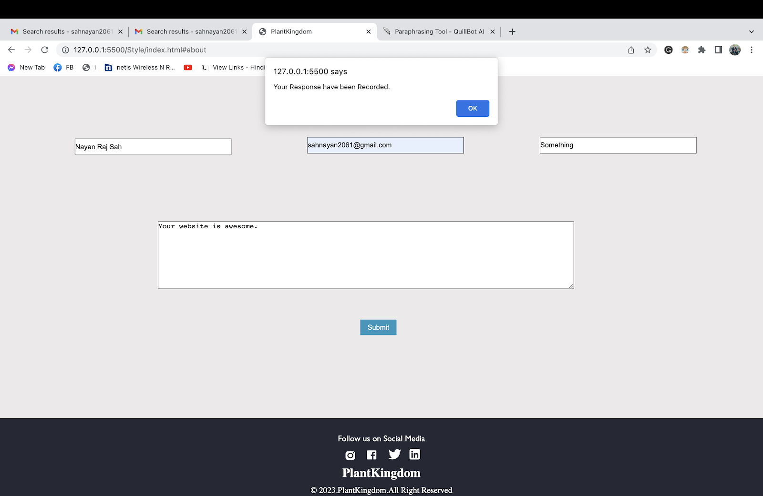

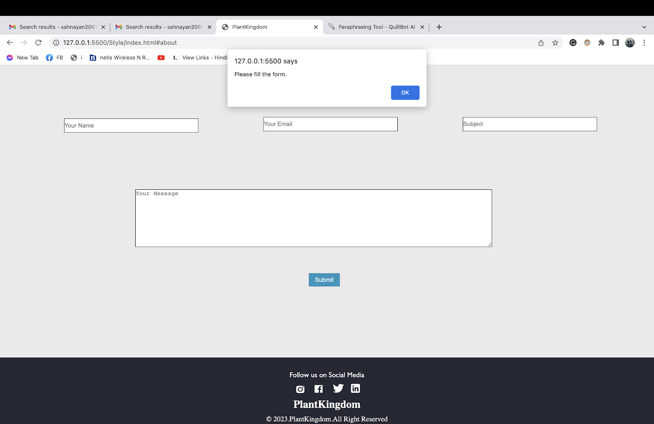



## **Testing: Typewriter JavaScript**

| Test no. | 3 |
| --- | --- |
| Action | Go to home page.  Observe that there is dynamically change in  The text of Plantkingdom, Indoor Bonsai, and Outdoor  Bonsai with writing effect. |
| Expected Output | There should be dynamically change in text. |
| Actual Output | Text has dynamically changed. |
| Conclusion | Test Successful |

*Table 3 : Testing: typewriter JavaScript*

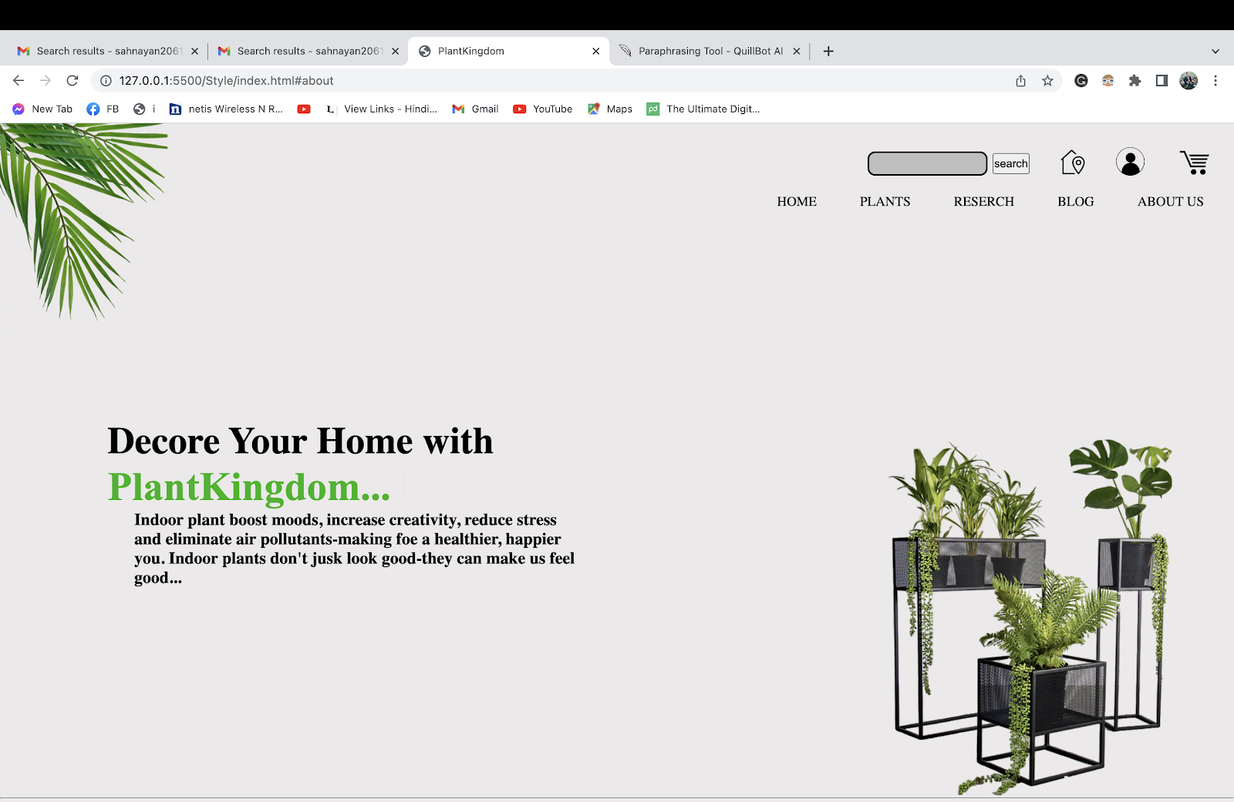

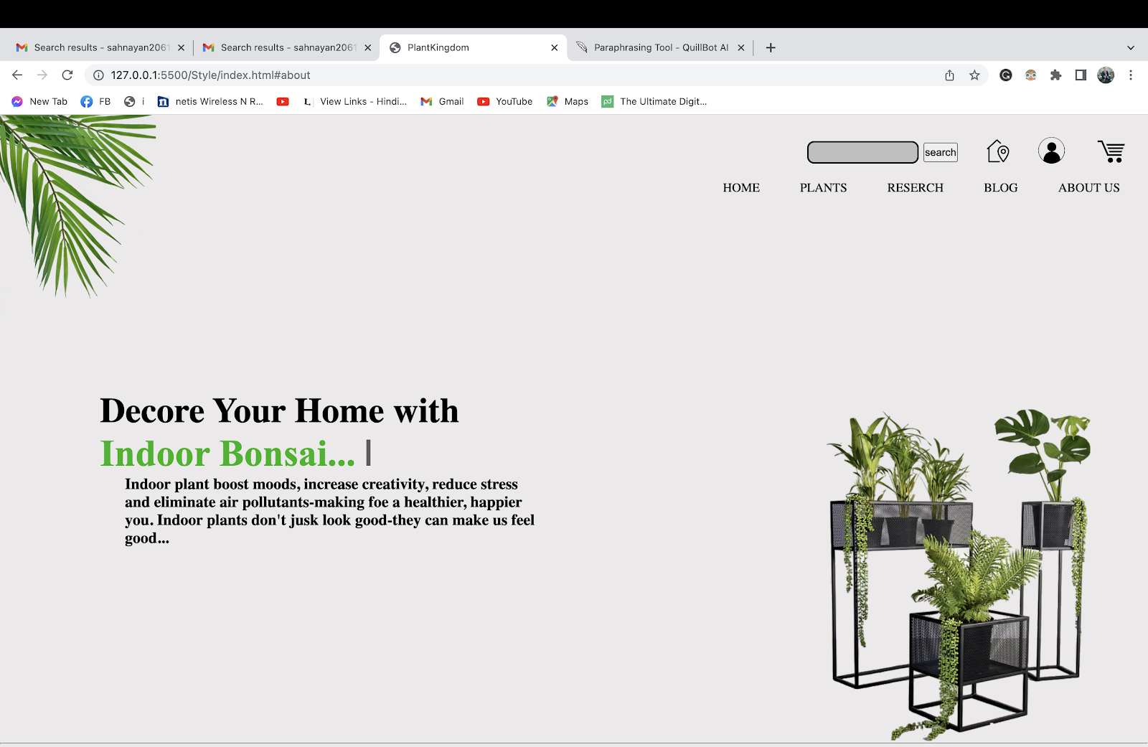

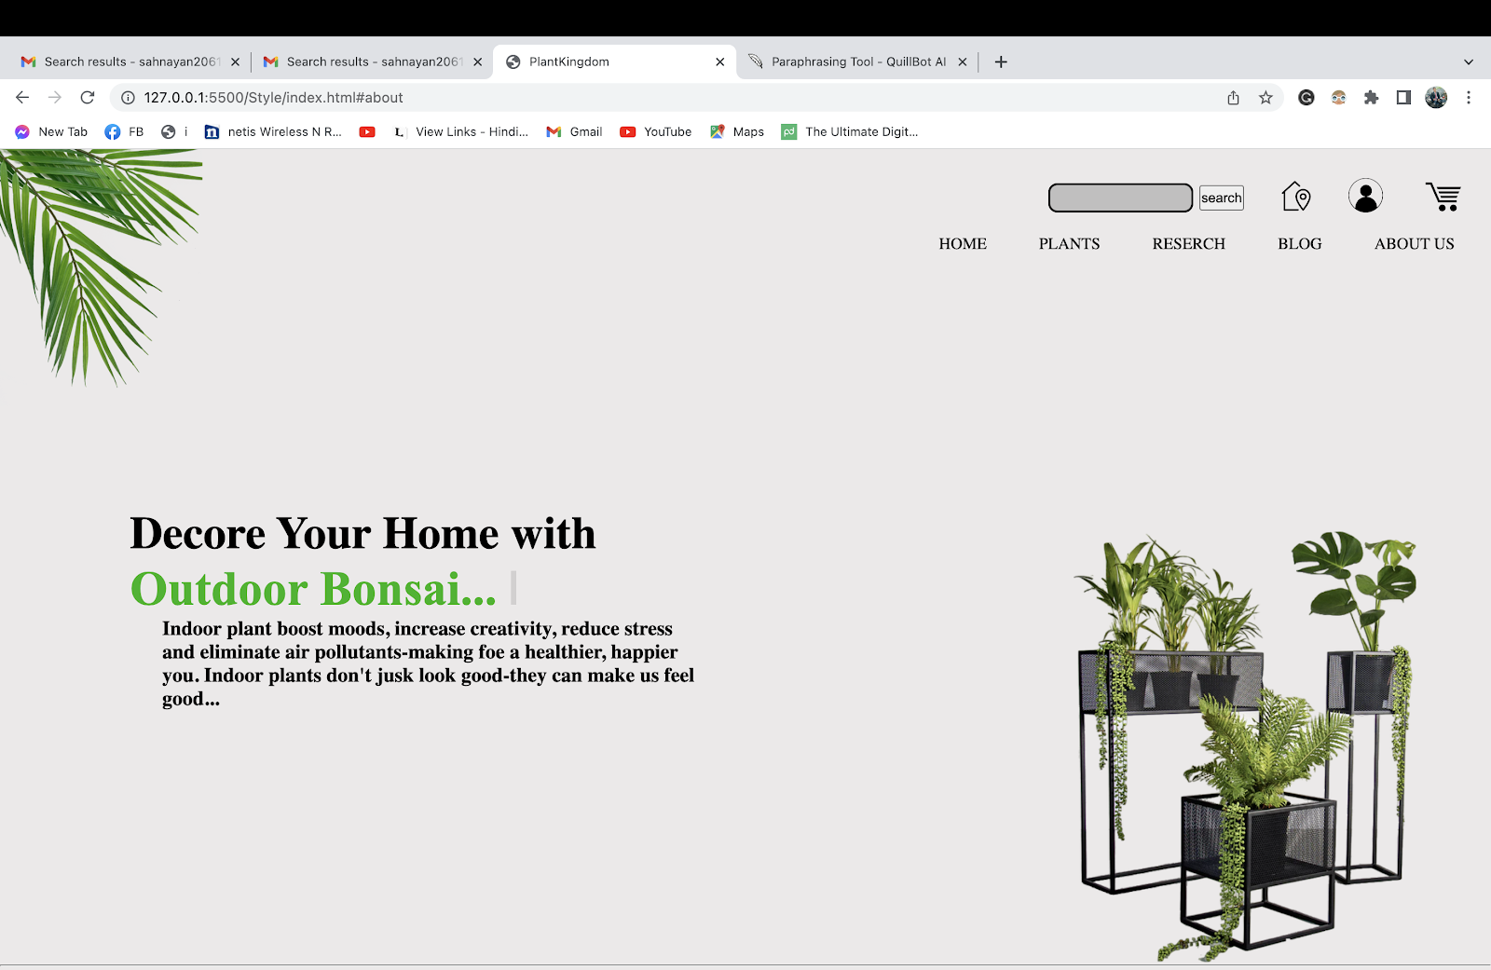

## **Testing: Hover effect on navigation bar.**

| Test no. | 4 |
| --- | --- |
| Action | Checking the hover on the navigation bar. |
| Expected Output | The word changes it colour and get highlighted than other ones. |
| Actual Output | The word changes it colour and got highlighted than other ones. |
| Conclusion | Test Successful |

*Table 4 : Testing: hover effect on navigation bar.*

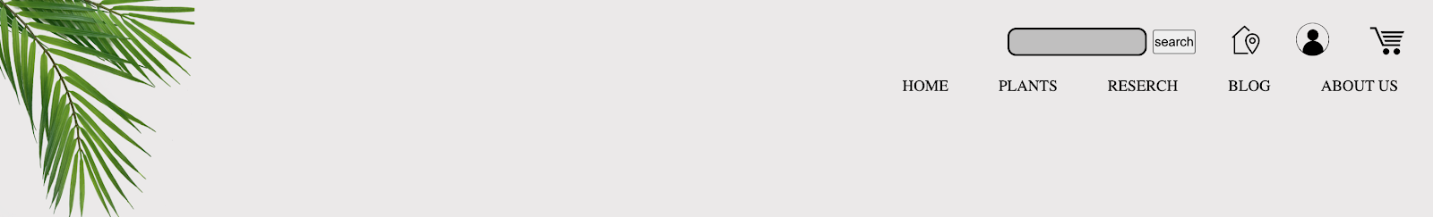



## **Testing: Internal and External links**

| Test no. | 5 |
| --- | --- |
| Action | Scroll to About Us section.  Click on any teammate photo.  Click on the any social media icon on portfolio  page. |
| Expected Output | After clicking on photo, you to another page.  After clicking on social media icon, you should get his personal social media handle. |
| Actual Output | Another page has opened and get social media handle. |
| Conclusion | Test Successful |

*Table 5 : Testing: Internal and External links.*

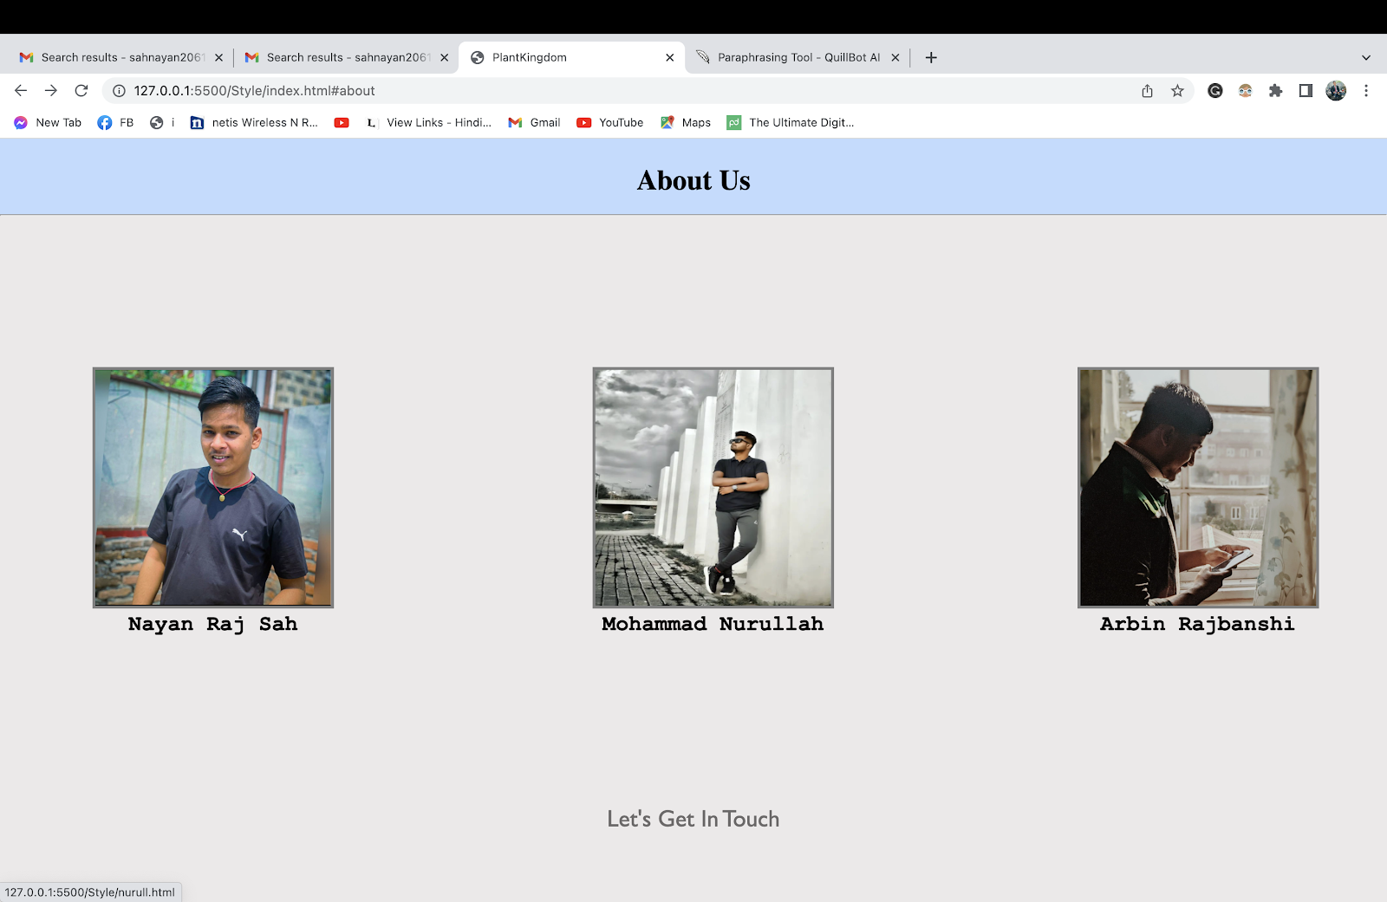

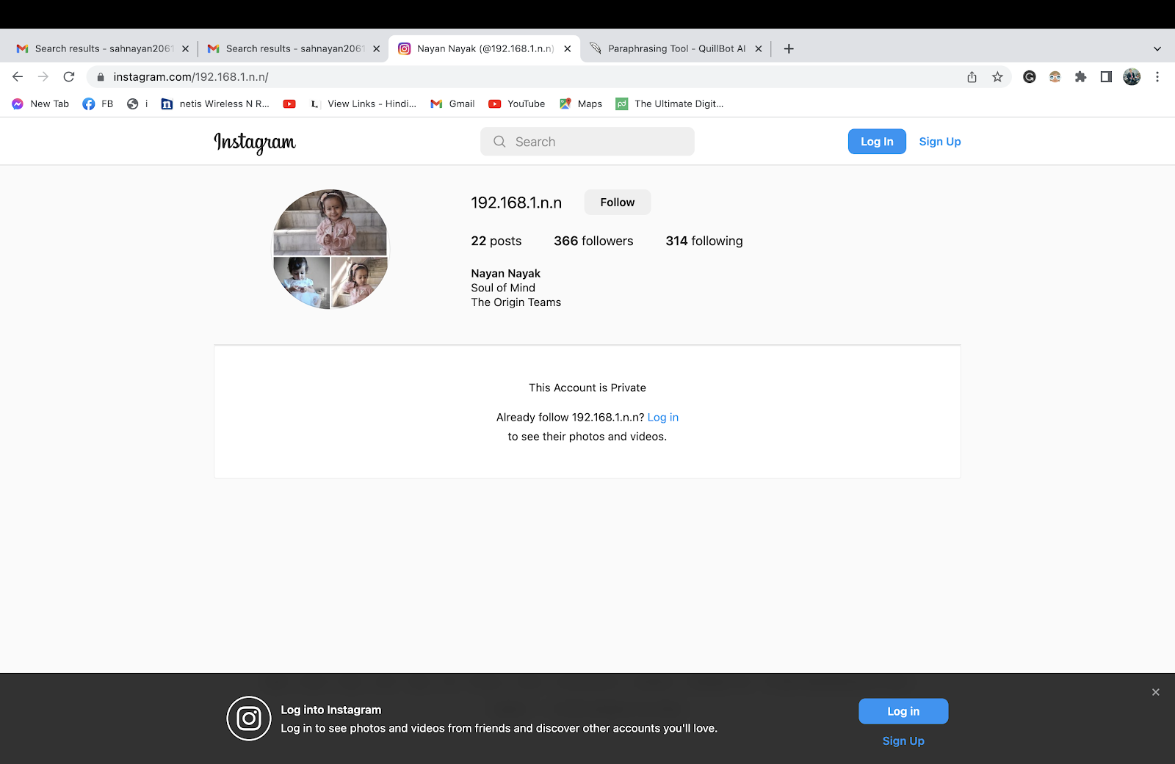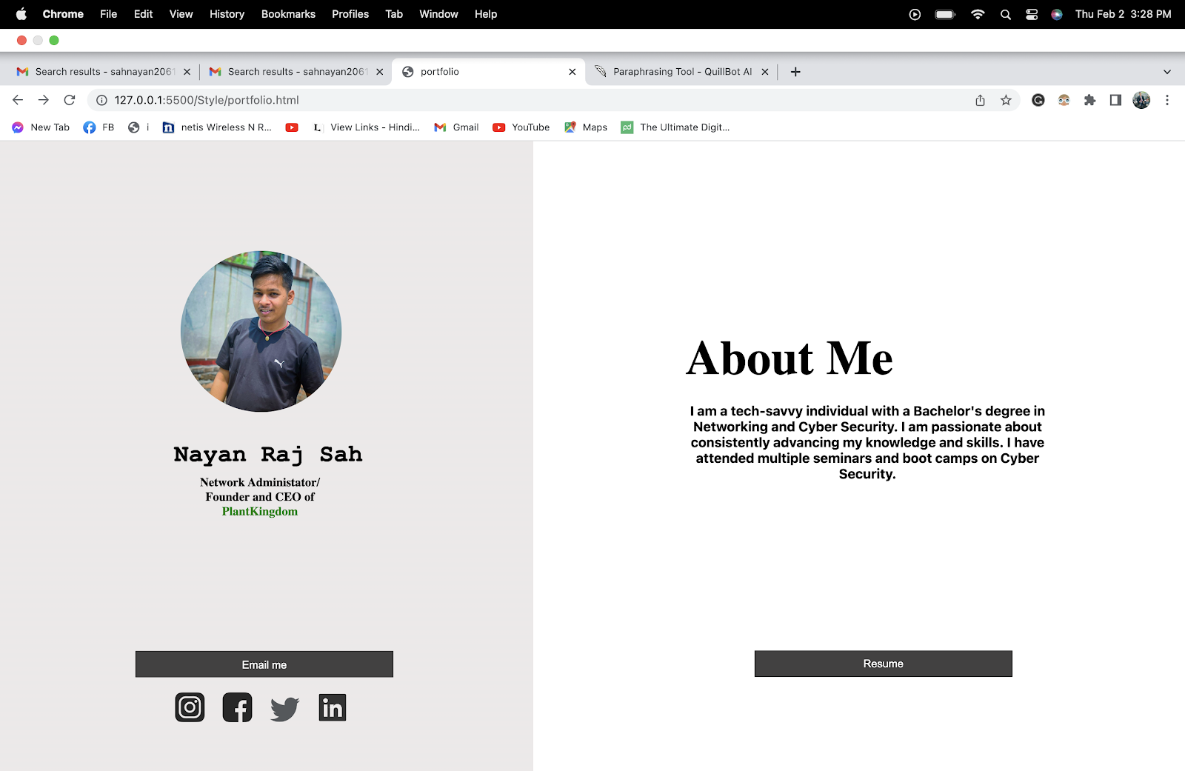



# **Conclusion**

We are required to develop a website for an e-commerce business bonsai plant that offers a products linked to decoration using HTML, CSS and JavaScript. In order to complete the assignment, it was necessary to develop a website, write a report, and compile the necessary papers. The HTML and CSS scripts are provided in addition to a condensed explanation of each tool that was applied. JavaScript was used in the process of developing the website’s dynamic content. Both the internal and external user experiences made use of CSS and JavaScript. Testing the contact validity, timings, and slider using JavaScript was the primary objective of this project. The tables must include both the expected results and the ones that came in for each test.

This is our first-time doing coursework, it was difficult at first to figure out how to do it but we with the help of our module teacher guidance we were able to complete our coursework. It was a really challenging experience to work on something that was very different than what we have experience so far, but it was also quite interesting and inspiring. After discovering how step the learning curve was, we were compelled to decide on how we would overcome it because of the multiple problems that we experience. In-depth research and new discoveries were necessary for this task. A few different topics were discussed, including HTML, CSS, JavaScript, and wireframes.

# **Bibliography**

balsamiq. (n.d.). *learn*. Retrieved january 30, 2023, from balsamiq: https://balsamiq.com/learn/articles/what-are-wireframes/

Barney, N. (n.d.). *definition*. Retrieved january 30, 2023, from techtarget: https://www.techtarget.com/searchmobilecomputing/definition/Google-Chrome-browser#:~:text=Google%20Chrome%20browser%20is%20a,issues%20several%20updates%20a%20year.

codecademy. (n.d.). *courses*. Retrieved january 27, 2023, from codecademy: https://www.codecademy.com/courses/introduction-to-javascript/lessons/introduction-to-javascript/exercises/intro

developer.mozilla. (n.d.). *docs*. Retrieved january 27, 203, from developer.mozilla: https://developer.mozilla.org/en-US/docs/Web/CSS

globallogic. (n.d.). *services*. Retrieved january 30, 2023, from globallogic: https://www.globallogic.com/services/offerings/atlassian/draw-io-for-confluence/

Heller, M. (2022, july 8). *article*. Retrieved january 30, 2023, from infoworld: https://www.infoworld.com/article/3666488/what-is-visual-studio-code-microsofts-extensible-code-editor.html

hostinger. (n.d.). *tutorials*. Retrieved january 27, 2023, from hostinger: https://www.hostinger.com/tutorials/what-is-html

testbook. (n.d.). *learn*. Retrieved january 30, 2023, from testbook: https://testbook.com/learn/microsoft-word/

usability. (n.d.). *how-to-and-tools*. Retrieved january 30, 2023, from usability: https://www.usability.gov/how-to-and-tools/methods/wireframing.html

# **Appendix**

**Source code of “Home page”**

<!DOCTYPE html>

<html lang="en">

<head>

<meta charset="UTF-8">

<meta http-equiv="X-UA-Compatible" content="IE=edge">

<meta name="viewport" content="width=device-width, initial-scale=1.0">

<title>PlantKingdom</title>

<link rel="stylesheet" href="../Style/style.css">

<style>

.navbar ul{

display: flex;

position: relative;

font-size: 100%;

top: 4rem;

width: 35rem;

left: 55rem;

margin: 20px;

justify-content: space-around;

}

.navbar ul li a {

text-decoration: none;

color: black;

}

.navbar li a:hover{

color: rgba(198, 99, 244, 0.951);

}

.navbar ul li {

list-style: none;

}

#search{

border-color: black;

background-color: rgb(192, 191, 191);

margin-top: 5px;

width: 220rem;

height: 25px;

border-radius: 9px;

}

.btn{

height: 25px;

margin-top: 7px;

margin-left: 6px;

}

.home{

position: relative;

width: 33px;

left: 35px;

top: 1px;

}

.sign{

position: relative;

width: 34px;

left: 70px;

top: 0px;

}

.cart{

position: relative;

width: 49px;

left: 105px;

top: -1rem;

margin-top: 18px;

}

.rightnav{

width: 14.5rem;

display: flex;

justify-content: space-around;

position: relative;

bottom: 30px;

left: 67rem;

}

.bodypic {

position: relative;

width: 390px;

height: 390px;

left: 63rem;

bottom: 50px;

}

.bodypic img{

width: 450px;

height: 450px;

position: relative;

/* left: 62rem; */

/* bottom: 170px; */

}

.png{

position: relative;

bottom: 10rem;

width: 300px;

height: 300px;

}

.png img{

position: relative;

width: 300px;

height: 300px;

/* bottom: 100px; */

transform: rotate(270deg);

}

.cato{

width: 200px;

font-size: large;

position: relative;

margin-left: 1rem;

top: 31.5rem;

}

.feature{

margin-left: 16rem;

position: relative;

padding-bottom: 10px;

border-radius: 2px;

}

.new{

margin-left: 16rem;

position: relative;

padding-bottom: 10px;

margin-top: 30px;

}

table {

cursor: pointer;

}

.product:hover{

transform: translateY(-5px);

}

.line{

background-color: red;

width: 1px;

height: 400px;

position: relative;

top: 30.5rem;

left: 200px;

}

.buy{

width: 15rem;

height: 2rem;

background-color: #2596be;

border: gray;

margin-top: 2rem;

border-radius: 5px;

}

.buy:hover{

background: #96cee3;

}

.add{

border-radius: 5px;

width: 15rem;

height: 2rem;

background-color: gray;

border: gray;

margin-top: 0.2rem;

}

.add:hover{

background: rgb(171, 171, 171);

}

.learn{

position: relative;

margin-right: 26rem;

bottom: 5px;

width: 80px;

height: 30px;

background-color: #2596be;

border-radius: 6px;

border: #2596be;

color: #fff;

}

.learn:hover{

background: #73bfda;

}

.name ul li a{

text-decoration: none;

}

.btn{

cursor: pointer;

}

input{

width: 300px;

height: 30px;

}

textarea{

width: 50rem;

height: 8rem;

}

.imgbor{

border: 3px solid gray;

}

.slider {

width: 500px;

height: 400px;

margin: 20px auto;

position: relative;

top: 2rem;

right: 2rem;

/*

box-sizing property allows us to include the padding and border in an element's total width and height.

*/

/*The overflow is clipped, and the rest of the content will be invisible*/

overflow: hidden;

}

#typewriter {

font-size: 20px;

font-family: monospace;

}

.cursor {

font-size: 3rem;

animation: blink 1s infinite;

color: rgb(93, 91, 91);

}

@keyframes blink {

0% {

opacity: 0;

}

50% {

opacity: 1;

}

100% {

opacity: 0;

}

}

.blog{

width: 100%;

height: 65rem;

position: relative;

bottom: 45rem;

background-image: linear-gradient(

to left,

#22452c 0%,

#c1e4cb 75%,

#ece9e9 55%,

#ece9e9 100%

);

}

.blogpi{

background-image: linear-gradient(

to left,

#ffffff 0%,

#a9a7a7 95%,

#ece9e9 55%,

#ece9e9 100%

);

}

.blogb:hover{

color: white;

background-color: #2596be;

}

.daily:hover{

transform: translateY(-9px);

}

.btn:hover{

background-color: #2596be;

color: white;

}

.btns{

position: relative;

top: 20rem;

left: 22rem;

background-color: transparent;

color: white;

height: 50px;

width: 200px;

border-color: #d58f2d;

border-radius: 50px;

cursor: pointer;

}

.btns:hover{

background-color: white;

color: #363d4c;

}

.research{

background-image: url(../image/\ bcpic.png);

}

</style>

</head>

<body>

<nav class="navbar">

<ul class="nav-list">

<li><a href="#home">HOME </a></li>

<li><a href="#feature-product">PLANTS</a></li>

<li><a href="#research-page">RESERCH</a></li>

<li><a href="#blog">BLOG</a></li>

<li><a href="#about">ABOUT US</a></li>

</ul>

<!--This is the navation bar of website.-->

<div class="rightnav">

<input type="text" name="search" id="search">

<button class="btn btn-sm">search</button>

<a

href="https://www.google.com/maps/place/Islington+College/@27.7076469,85.3263895,18.13z/data=!4m5!3m4!1s0x39eb1908434cb3c5:0x1fdf1a6d41d2512d!8m2!3d27.7076565!4d85.3252362">

<img src="../image/ home.png" class="home">

</a>

<a href="../Style/login.html"><img src="../image/ signin.png" class="sign"></a>

<a href="../Style/cart.html">

<div

style="color: white; position: relative; left: 8.7rem; background-color: red; width: 20px; text-align: center; border-radius: 100px; bottom: 5px;display: none ; "

id="cartCount">0</div>

<img src="../image/ cart.png" class="cart" id="cart_fix">

</a>

</div>

</nav>

<!--This is some shortcut for visiters.-->

<section class="png">

<img src="../image/leaf1.png" alt="">

<section class="title">

<h1 style="width: 470px; font-size: 45px; margin-left: 8rem; margin-top: 95px; ">Decore Your Home with

<br> <span id="typewriter" style="color: rgb(11, 181, 11); font-size: 3rem; font-family: 'Times New Roman', Times, serif; "></span>

<span id="cursor" class="cursor">|</span>

</h1>

</section>

<section class="discription">

<h5 style="width:550px; margin-left: 10rem; font-size: 20px; top: 5rem;"> Indoor plant boost moods, increase creativity,

reduce stress<br>

and eliminate air pollutants-making foe a healthier, happier<br>

you. Indoor plants don't jusk look good-they can make us feel<br>

good...</h5>

</section>

</section>

<!--This section for Top image and short discription for website.-->

<figure class="bodypic">

<img src="../image/ bodypic.png">

</figure>

<hr>

<!--this is the red line code-->

<div class="line"></div>

<section style="position: relative; bottom: 260px;">

<!--This section is for plant catagories-->

<div class="cato">

<h3 style="font-size: 25px; margin-bottom: 10px; text-align: center;"><b>Bonsai Plant</b> </h3>

<p style="font-family: 'Courier New', Courier, monospace; font-size: 15px; text-align: center;"><a

href="indoor.html" style="text-decoration: none; color: green;">Indoor Bonsai</a></p>

<p style="font-family: 'Courier New', Courier, monospace; font-size: 15px; text-align: center;"><a

href="outdoor.html" style="text-decoration: none; color: green;">Outdoor Bonsai</a></p>

<p style="font-family: 'Courier New', Courier, monospace; font-size: 15px; text-align: center;"><a

href="flowering.html" style="text-decoration: none; color: green;">Flowering Bonsai </a></p>

</div>

<table width="89%" style="position: relative; margin-left: 10rem;">

<h2 id="feature-product" class="feature"> Feature Product</h2>

<tr>

<th class="product">

<section>

<img src="../image/ abana.jpg" alt="Abana Plant" width="250px" height="250px">

<h4>Abana Home Bonsai<br> Live Plant</h4>

<p><del><span style="color: black;">NRP 399 </span> </del></p>

<p><span style="color: red;">NRP 349 </span></p>

<p><span style="color: rgb(243, 112, 18);">(Limited in stock)</span></p>

<div>

<button type="btn" class="buy"><span style="color: white;">Buy Now</span></button>

</div>

<div>

<button onclick="updateCartCount()" type="btn" class="add" id="addButton"><span style="color: white;">Add

To Cart</span></button>

</div>

</section>

</th>

<th class="product">

<section>

<img src="../image/ chinese.jpg" alt="Chinese Elm" width="263px" height="263px">

<h4>Chinese Elm</h4>

<p><del><span style="color: black;">NRP 3499 </span> </del></p>

<p><span style="color: red;">NRP 3199 </span></p>

<div>

<button type="btn" class="buy"><span style="color: white;">Buy Now</span></button>

</div>

<div>

<button onclick="updateCartCount()" type="btn" class="add" id="addButton"><span style="color: white;">Add To Cart</span></button>

</div>

</section>

</th>

<th class="product">

<section>

<img src="../image/ fejka.jpg" alt="FEJKA Artifical" width="250px" height="250px">

<h4>FEJKA Artifical<br>Potted plant</h4>

<p><del><span style="color: black;">NRP 2999 </span> </del></p>

<p><span style="color: red;">NRP 2499 </span></p>

<div>

<button type="btn" class="buy"><span style="color: white;">Buy Now</span></button>

</div>

<div>

<button onclick="updateCartCount()" type="btn" class="add" id="addButton"><span style="color: white;">Add To Cart</span></button>

</div>

</section>

</th>

</tr>

</table>

</section>

<!--This section and table is for Feature Product.-->

<section style="position: relative; bottom: 200px;">

<h2 class="new">New Arrival</h2>

<table width="89%" style="position: relative; margin-left: 10rem;">

<tr>

<th class="product">

<section>

<img src="../image/ jada.jpg" alt="Jada Plant" width="250px" height="250px">

<h4> Jada Plant Bonsai</h4>

<p><del><span style="color: black;">NRP 6990 </span> </del></p>

<p><span style="color: red;">NRP 6690 </span></p>

<div>

<button type="btn" class="buy"><span style="color: white;">Buy Now</span></button>

</div>

<div>

<button onclick="updateCartCount()" type="btn" class="add" id="addButton"><span style="color: white;">Add To Cart</span></button>

</div>

</section>

</th>

<th class="product">

<section>

<img src="../image/ monterey.jpg" alt="Monterey Pine" width="250px" height="250px">

<h4> Monterey Pine Sapling<br> Starter</h4>

<p><del><span style="color: black;">NRP 4990 </span> </del></p>

<p><span style="color: red;">NRP 4590 </span></p>

<div>

<button type="btn" class="buy"><span style="color: white;">Buy Now</span></button>

</div>

<div>

<button onclick="updateCartCount()" type="btn" class="add" id="addButton"><span style="color: white;">Add To Cart</span></button>

</div>

</section>

</th>

<th class="product">

<section>

<img src="../image/ traditional.jpg" alt="Traditional Juniper" width="250px" height="250px">

<h4>Traditional Juniper </h4>

<p><del><span style="color: black;">NRP 6990 </span> </del></p>

<p><span style="color: red;">NRP 6690 </span></p>

<p><span style="color: rgb(228, 21, 21);;">(Out Of Stock)</span></p>

<div>

<button type="btn" class="buy"><span style="color: white;">Buy Now</span></button>

</div>

<div>

<button type="btn" class="add" id="addButton"><span style="color: white;">Add To Cart</span></button>

</div>

</section>

</th>

</tr>

</table>

</section>

<!--This sections is for Research Page-->

<div style="width: 100%; height: 97rem;" id="research-page" class="research">

<p style="position: relative; top: 12rem; ">

<span style="color: white; position: relative; left: 4.2rem; font-size: 55px;"> <b>Enhancing Clarity and Conciseness,</b></span><br>

<span style="color: white; position: relative; left: 4.2rem; font-size: 40px; color: #d58f2d;"> from where and what we Researches?</span>

</p>

<p style="position: relative; top: 14rem; color: white; font-family: 'Gill Sans', 'Gill Sans MT', Calibri, 'Trebuchet MS', sans-serif; font-size: 20px;">

<span style="position: relative; left: 7rem;">

The research page, which includes a research section, should compare the elements we <br>

utilize on our website with those of the website we plan to explore for research.</span>

</p>

<a href="../Style/research.html">

<button type="button" class="btns">Read Research </button></a>

</div>

<!--This section for Blog Page-->

<div class="blog" id="blog">

<h2 style="text-align: right; position: relative; right: 29rem; color: white; top: 2rem;">BLOG</h2>

<a href="../Style/blog.html" style="text-decoration: none;">

<p style="position: relative; text-align: right; top: 20rem; right: 15rem; font-size: 35px; color: #dadebd;">

Our Journey To Bonsai Plant lovers <br>

<span style="position: relative; right: 6rem;"> to Entrepreneur...</span>

</p>

</a>

<p style="position: relative; text-align: right; top: 20.4rem; font-size: 13px; right: 19rem;">

We have a hobby or will we say some sort of affection towards<br>

bonsai plant since we was a kids. As I remember the very first..

</p>

<a href="../Style/daily.html">

<img src="../image/ daily.jpg" width="250px" height="220px" style="position: relative; top: 35rem; left: 50rem;" class="daily"></a>

<a href="../Style/daily.html" style="text-decoration: none;">

<p style="position: relative; top: 35rem; text-align: right; right: 28.5rem; color: white;">Impact of technology in our<br>

<span style="position: relative; right: 2.5rem;"> Daily Life.</span>

</p>

</a>

<a href="../Style/technolgy.html">

<img src="../image/business.webp" width="250px" height="220px" style="position: relative; top: 18.8rem; left: 73rem;" class="daily"></a>

<a href="../Style/technolgy.html" style="text-decoration: none;">

<p style="position: relative; top: 19rem; text-align: right; right: 5rem; color: white; ">

How does technology affect <br>

<span style="position: relative; right: 2rem; "> our business?</span>

</p>

</a>

<div class="blogpi" style="position: relative; background-color: #e0dfe1; width: 40rem; height: 30rem; bottom: 33rem; left: 5rem;">

<!--image slider-->

<div class="slider">

<div id="lamo">

<img src="batman/twaiban.png">

</div>

</div>

</div>

<div>

<button style="position: relative; bottom: 25rem; left: 16.5rem; width: 200px; height: 50px; border-radius: 10rem; border-color: #22452c; cursor: pointer; " class="blogb" type="button">ReadMore Blogs</button>

</div>

</div>

</div>

<!--This section is for About Us-->

<div id="about" style="background-color: #bfdcff; position: relative; bottom: 45rem; width: 100%; height: 80px;">

<h1 style="text-align: center; position: relative; top: 27px; font-size: 30px;">About Us</h1>

<hr style="position: relative; top: 45.4px; color: black;">

</div>

<section style="position: relative; bottom: 35em;">

<table>

<tr>

<th>

<section style="position: relative; left: 6rem;">

<a href="../Style/portfolio.html" style="text-decoration: none;">

<img class="imgbor" src="../image/ Nayan.png" width="250px" height="250px">

<p class="name"><span

style="color: black;font-family: 'Courier New', Courier, monospace; position: relative;font-size: 23px; ">Nayan

Raj Sah</span></p>

</a>

</section>

</th>

<th>

<section style="position: relative; left: 23rem;">

<a href="../Style/nurull.html" style="text-decoration: none;">

<img class="imgbor" src="../image/nurull.png" width="250px" height="250px">

<p class="name"><span

style="color: black;font-family: 'Courier New', Courier, monospace; position: relative;font-size: 23px; ">Mohammad

Nurullah</span></p>

</a>

</section>

</th>

<th>

<section style="position: relative; left: 39rem;">

<a href="../Style/arbin.html" style="text-decoration: none;">

<img class="imgbor" src="../image/ arbin.jpg" width="250px" height="250px">

<p class="name"><span

style="color: black;font-family: 'Courier New', Courier, monospace; position: relative; font-size: 23px; ">Arbin

Rajbanshi</span></p>

</a>

</section>

</th>

</tr>

</table>

</section>

<p

style="position: relative; text-align: center; font-family: 'Gill Sans', 'Gill Sans MT', Calibri, 'Trebuchet MS', sans-serif; font-size: 25px; bottom: 24rem; color: rgb(109, 107, 107); ">

Let's Get In Touch</p>

</div>

<section style="position: relative; bottom: 18rem;">

<table>

<tr>

<th>

<section style="position: relative; left: 6rem;">

<img src="../image/icones-de-localisation-de-la-carte-grise.png" width="60px" height="50px">

<p><span

style="color: black; font-family: Cambria, Cochin, Georgia, Times, 'Times New Roman', serif; position: relative;font-size: 15px; color: gray;">Address</span>

</p>

<p

style="font-family: 'Gill Sans', 'Gill Sans MT', Calibri, 'Trebuchet MS', sans-serif; font-size: 15px; color: gray;">

Kamalpokhari, kathmandu</p>

</section>

</th>

<th>

<section style="position: relative; left: 19rem;">

<img src="../image/ phone.png" width="50px" height="50px">

<p><span

style="color: black; font-family: Cambria, Cochin, Georgia, Times, 'Times New Roman', serif; position: relative;font-size: 15px;color: gray ; ">Phone</span>

</p>

<p

style="font-family: 'Gill Sans', 'Gill Sans MT', Calibri, 'Trebuchet MS', sans-serif; font-size: 15px; color: gray;">

9824736656</p>

</section>

</th>

<th>

<section style="position: relative; left: 30rem;">

<img src="../image/ email.png" width="50px" height="50px">

<p><span

style="color: black; font-family: Cambria, Cochin, Georgia, Times, 'Times New Roman', serif; position: relative;font-size: 15px; color: gray; ">E-mail</span>

</p>

<p

style="font-family: 'Gill Sans', 'Gill Sans MT', Calibri, 'Trebuchet MS', sans-serif; font-size: 15px; color: gray;">

admin@plantkingdom.com</p>

</section>

</th>

<th>

<section style="position: relative; left: 42rem;">

<img src="../image/ clock.png" width="50px" height="50px">

<p><span

style="color: black; font-family: Cambria, Cochin, Georgia, Times, 'Times New Roman', serif; position: relative; font-size: 15px; color: gray; ">Working

Hours</span></p>

<p

style="font-family: 'Gill Sans', 'Gill Sans MT', Calibri, 'Trebuchet MS', sans-serif; font-size: 15px; color: gray;">

Monday-Friday: 6am-6pm</p>

</section>

</th>

</tr>

</table>

</section>

<!--This is Validations Form-->

<div class="container" style="position: relative;"></div>

<input style="position: relative; left: 9rem; bottom: 7rem; border-color: rgb(37, 41, 53); border-width: 1px;"

type="text" placeholder="Your Name" required>

</div>

<div class="container">

<input style="position: relative; left: 37rem; bottom: 9.2rem; border-color: rgb(37, 41, 53); border-width: 1px;"

type="email" placeholder="Your Email" id="email" required>

</div>

<div>

<input

style="position: relative; left: 65rem; bottom: 11.2rem; border-color: rgb(37, 41, 53); border-width: 1px;"

type="text" placeholder="Subject" required>

</div>

<textarea style="position: relative; left: 19rem; bottom: 3rem; border-color: rgb(37, 41, 53);" type="text"

placeholder="Your Message"></textarea>

<div>

</div>

<section>

<div>

<button class="btn"

style="position: relative; left: 43rem; bottom: 0rem; width: 70px; height: 30px; background-color: #2596be; border: #2596be; color: white;"

type="button" onclick="return submit()"> Submit</button>

</div>

<!-- This section is for Footer Section-->

<div style="background-color: rgb(37, 41, 53); height: 150px; position: relative; bottom: -10rem; "

class="footer">

<p

style="text-align: center; font-family: 'Gill Sans', 'Gill Sans MT', Calibri, 'Trebuchet MS', sans-serif; margin-bottom: 10px; color: white; padding-top: 30px;">

Follow us on Social Media</p>

<div style="position: relative; top: -6px;">

<img src="../image/ insta.png" style="width: 25px; height: 20px;position: relative; left: 41.4rem; ">

<img src="../image/ facebook.png"

style="width: 30px; height: 30px; position: relative; left: 42rem; top: 4px;">

<img src="../image/ twitter.png" style="width: 25px; height: 25px; position: relative; left: 42.8rem;">

<img src="../image/ linkedin.png" style="width: 25px; height: 25px; position: relative; left: 43.4rem;">

</div>

<h2 style="position: relative; text-align: center; margin-bottom: 10px; color: white;">PlantKingdom</h2>

<p style="color: white; text-align: center;">&#169 2023.PlantKingdom.All Right Reserved</p>

</div>

</section>

<script>

//function for submit to newsletter

function submit() {

var element = document.getElementById("email");

if(element.checkValidity()) {

//if valid email entered

alert("Your Response have been Recorded.")

document.getElementById("subscribe").reset();

return false;

}

else{

alert("Please fill the form.")

}

}

//Image slider

var images = ['batman/scrpit.png', 'batman/twaiban.png'];

var x = 0;

var imgs = document.getElementById('lamo');

//The setInterval() calls a function at theintervals (in milliseconds).

setInterval(slider, 3000);

function slider() {

if (x < images.length) {

x = x + 1;

}

else {

x = 1;

}

imgs.innerHTML = "<img src=" + images[x - 1] + ">";

}

//typewrite javascript

var text = ["PlantKingdom...", "Indoor Bonsai... ","Outdoor Bonsai..."];

var i = 0;

var j = 0;

var cursor = true;

function typeWriter() {

if (i < text.length) {

var currentText = text[i];

if (j < currentText.length) {

document.getElementById("typewriter").innerHTML += currentText.charAt(j);

j++;

} else {

i++;

j = 0;

document.getElementById("typewriter").innerHTML = "";

setTimeout(typeWriter, 3000); // delay of 2 seconds before typing the next text

}

} else {

i = 0;

setTimeout(typeWriter,3000);

}

}

setInterval(typeWriter, 300);

setInterval(function(){

cursor = !cursor;

document.getElementById("cursor").style.visibility = cursor ? "visible" : "hidden";

}, 400);

</script>

<Script src="../Style/index.js"></Script>

</body>

</html>

**Source code of “Indoor Bonsai page”**

<!DOCTYPE html>

<html>

<head>

<style>

body{

background-color: #ece9e9;

}

.cato{

width: 200px;

font-size: large;

position: relative;

margin-left: 1rem;

top: 29.5rem;

}

.indoor{

margin-left: 16rem;

position: relative;

}

.product:hover{

transform: translateY(-9px);

}

.line{

background-color: red;

width: 1px;

height: 400px;

position: relative;

top: 13.5rem;

left: 200px;

}

.buy{

width: 15rem;

height: 2rem;

background-color: #2596be;

border: gray;

margin-top: 1rem;

border-radius: 5px;

}

.buy:hover{

background: #96cee3;

}

.add{

border-radius: 5px;

width: 15rem;

height: 2rem;

background-color: gray;

border: gray;

margin-top: 0.2rem;

}

.add:hover{

background: rgb(171, 171, 171);

}

</style>

</head>

<body>

<!--This section for the 1st table for indoor plants-->

<div class="line"></div>

<section style="position: relative; bottom: 530px;">

<!--This is the catogies of plant section-->

<div class="cato">

<h3 style="font-size: 25px; margin-bottom: 5px; text-align: center;">Bonsai Plant </h3>

<p style="font-family: 'Courier New', Courier, monospace; font-size: 15px; text-align: center; margin-top: 0%; margin-bottom: 0%; color: green;" >Indoor Bonsai</p>

<p style="font-family: 'Courier New', Courier, monospace; font-size: 15px; text-align: center; margin-top: 0%; margin-bottom: 0%;"><a href="outdoor.html" style="text-decoration: none; color: green;">Outdoor Bonsai</a></p>

<p style="font-family: 'Courier New', Courier, monospace; font-size: 15px; text-align: center; margin-top: 0%;"><a href="flowering.html" style="text-decoration: none; color: green;">Flowering Bonsai</a></p>

</div>

<h2 id="indoor-plant" class="indoor">Indoor Bonsai</h2>

<table width="89%" style="position: relative; margin-left: 10rem;">

<tr>

<th class="product">

<section>

<img src="../image/Ficus_bonsai.jpg" alt="Abana Plant" width="250px" height="250px">

<h4 style="margin-bottom: 3px;">Ficus bonsai <br> Plant</h4>

<p style="margin-top: 0%; margin-bottom: 0%;"><del><span style="color: black;">NRP 8399 </span> </del></p>

<p style="margin-top: 0%;"><span style="color: red;">NRP 8049 </span></p>

<!-- <p><span style="color: rgb(243, 112, 18);">(Limited in stock)</span></p> -->

<div>

<button type="button" class="buy"><span style="color: white;">Buy Now</span></button>

</div>

<div>

<button onclick="updateCartCount()" id="addButton" type="button" class="add"><span style="color: white;">Add To Cart</span></button>

</div>

</section>

</th>

<th class="product">

<section>

<img src="../image/Fukien_tea_bonsai.jpg" alt="Chinese Elm" width="263px" height="263px">

<h4 style="margin-bottom: 3px;">Fukien tea bonsai</h4>

<p style="margin-top: 0%; margin-bottom: 0%;"><del><span style="color: black;">NRP 5349 </span> </del></p>

<p style="margin-top: 0%;"><span style="color: red;">NRP 5119 </span></p>

<div>

<button type="button" class="buy"><span style="color: white;">Buy Now</span></button>

</div>

<div>

<button type="button" class="add"><span style="color: white;">Add To Cart</span></button>

</div>

</section>

</th>

<th class="product">

<section>

<img src="../image/Jade_bonsai.jpg" alt="FEJKA Artifical" width="250px" height="250px">

<h4 style="margin-bottom: 3px;">Jade bonsai</h4>

<p style="margin-top: 0%; margin-bottom: 0%;"><del><span style="color: black;">NRP 1299 </span> </del></p>

<p style="margin-top: 0%;"><span style="color: red;">NRP 1149 </span></p>

<div>

<button type="button" class="buy"><span style="color: white;">Buy Now</span></button>

</div>

<div>

<button type="button" class="add"><span style="color: white;">Add To Cart</span></button>

</div>

</section>

</th>

</tr>

</table>

</section>

<!--This is second table for indoor plants-->

<section style="position: relative; bottom: 500px;">

<table width="89%" style="position: relative; margin-left: 10rem;">

<tr>

<th class="product">

<section>

<img src="../image/Chinese_elm_bonsai.png" alt="Jada Plant" width="250px" height="250px">

<h4 style="margin-bottom: 3px;"> Chinese elm bonsai</h4>

<p style="margin-top: 0%; margin-bottom: 0%;"><del><span style="color: black;">NRP 2699 </span> </del></p>

<p style="margin-top: 0%;"><span style="color: red;">NRP 2369 </span></p>

<div>

<button type="button" class="buy"><span style="color: white;">Buy Now</span></button>

</div>

<div>

<button type="button" class="add"><span style="color: white;">Add To Cart</span></button>

</div>

</section>

</th>

<th class="product">

<section>

<img src="../image/Dwarf_umbrella_bonsai.jpg" alt="Monterey Pine" width="250px" height="250px">

<h4 style="margin-bottom: 3px;"> Dwarf umbrella <br> bonsai</h4>

<p style="margin-top: 0%; margin-bottom: 0%;"><del><span style="color: black;">NRP 4499 </span> </del></p>

<p style="margin-top: 0%;"><span style="color: red;">NRP 4259 </span></p>

<div>

<button type="button" class="buy"><span style="color: white;">Buy Now</span></button>

</div>

<div>

<button type="button" class="add"><span style="color: white;">Add To Cart</span></button>

</div>

</section>

</th>

<th class="product">

<section>

<img src="../image/Sacred_bamboo_bonsai.jpg" alt="Traditional Juniper" width="250px" height="250px">

<h4 style="margin-bottom: 3px;">Sacred bamboo bonsai </h4>

<p style="margin-top: 0%; margin-bottom: 0%;"><del><span style="color: black;">NRP 3699 </span> </del></p>

<p style="margin-top: 0%;"><span style="color: red;">NRP 3569 </span></p>

<!-- <p><span style="color: rgb(228, 21, 21);;">(Out Of Stock)</span></p> -->

<div>

<button type="button" class="buy"><span style="color: white;">Buy Now</span></button>

</div>

<div>

<button type="button" class="add"><span style="color: white;">Add To Cart</span></button></div>

</section>

</th>

</tr>

</table>

</section>

</body>

</html>

**Source code of “Outdoor Bonsai page”**

<!DOCTYPE html>

<html>

<head>

<style>

body{

background-color: #ece9e9;

}

.cato{

width: 200px;

font-size: large;

position: relative;

margin-left: 1rem;

top: 29.5rem;

}

.indoor{

margin-left: 16rem;

position: relative;

}

.product:hover{

transform: translateY(-9px);

}

.line{

background-color: red;

width: 1px;

height: 400px;

position: relative;

top: 13.5rem;

left: 200px;

}

.buy{

width: 15rem;

height: 2rem;

background-color: #2596be;

border: gray;

margin-top: 1rem;

border-radius: 5px;

}

.buy:hover{

background: #96cee3;

}

.add{

border-radius: 5px;

width: 15rem;

height: 2rem;

background-color: gray;

border: gray;

margin-top: 0.2rem;

}

.add:hover{

background: rgb(171, 171, 171);

}

</style>

</head>

<body>

<!--This section for the 1st table for indoor plants-->

<div class="line"></div>

<section style="position: relative; bottom: 530px;">

<!--This is the catogies of plant section-->

<div class="cato">

<h3 style="font-size: 25px; margin-bottom: 5px; text-align: center;"><b>Bonsai Plant</b> </h3>

<p style="font-family: 'Courier New', Courier, monospace; font-size: 15px; text-align: center; margin-top: 0%; margin-bottom: 0%;"><a href="indoor.html" style="text-decoration: none; color: green;">Indoor Bonsai</a></p>

<p style="font-family: 'Courier New', Courier, monospace; font-size: 15px; text-align: center; margin-top: 0%; margin-bottom: 0%; color: green;">Outdoor Bonsai</p>

<p style="font-family: 'Courier New', Courier, monospace; font-size: 15px; text-align: center; margin-top: 0%;"><a href="flowering.html" style="text-decoration: none; color: green;">Flowering Bonsai</a></p>

</div>

<h2 id="indoor-plant" class="indoor">Outdoor Bonsai</h2>

<table width="89%" style="position: relative; margin-left: 10rem;">

<tr>

<th class="product">

<section>

<img src="../image/artificial-outdoor-bonsai-pinus-tree-80-cm-with-5.jpg" alt="Abana Plant" width="250px" height="250px">

<h4 style="margin-bottom: 3px;">Artificial outdoor Bonsai <br> Pinus plant</h4>

<p style="margin-top: 0%; margin-bottom: 0%;"><del><span style="color: black;">NRP 9399 </span> </del></p>

<p style="margin-top: 0%;"><span style="color: red;">NRP 9049 </span></p>

<!-- <p><span style="color: rgb(243, 112, 18);">(Limited in stock)</span></p> -->

<div>

<button type="button" class="buy"><span style="color: white;">Buy Now</span></button>

</div>

<div>

<button type="button" class="add"><span style="color: white;">Add To Cart</span></button>

</div>

</section>

</th>

<th class="product">

<section>

<img src="../image/ ob.jpg" alt="Chinese Elm" width="263px" height="263px">

<h4 style="margin-bottom: 3px;">Live Dwarf Australian Weeping<br> Willow Bonsai</h4>

<p style="margin-top: 0%; margin-bottom: 0%;"><del><span style="color: black;">NRP 7349 </span> </del></p>

<p style="margin-top: 0%;"><span style="color: red;">NRP 7119 </span></p>

<div>

<button type="button" class="buy"><span style="color: white;">Buy Now</span></button>

</div>

<div>

<button type="button" class="add"><span style="color: white;">Add To Cart</span></button>

</div>

</section>

</th>

<th class="product">

<section>

<img src="../image/ed28181b-ce94-46fc-9ed3-1881df0dede4_1.3f6a82de9424ddc5a36122449b8330ee.jpeg" alt="FEJKA Artifical" width="250px" height="250px">

<h4 style="margin-bottom: 3px;">Brussel's Green Mound <br>Juniper Bonsai</h4>

<p style="margin-top: 0%; margin-bottom: 0%;"><del><span style="color: black;">NRP 3299 </span> </del></p>

<p style="margin-top: 0%;"><span style="color: red;">NRP 3149 </span></p>

<div>

<button type="button" class="buy"><span style="color: white;">Buy Now</span></button>

</div>

<div>

<button type="button" class="add"><span style="color: white;">Add To Cart</span></button>

</div>

</section>

</th>

</tr>

</table>

</section>

<!--This is second table for indoor plants-->

<section style="position: relative; bottom: 500px;">

<table width="89%" style="position: relative; margin-left: 10rem;">

<tr>

<th class="product">

<section>

<img src="../image/Chinese_elm_bonsai.png" alt="Jada Plant" width="250px" height="250px">

<h4 style="margin-bottom: 3px;"> Chinese elm bonsai</h4>

<p style="margin-top: 0%; margin-bottom: 0%;"><del><span style="color: black;">NRP 4699 </span> </del></p>

<p style="margin-top: 0%;"><span style="color: red;">NRP 4369 </span></p>

<div>

<button type="button" class="buy"><span style="color: white;">Buy Now</span></button>

</div>

<div>

<button type="button" class="add"><span style="color: white;">Add To Cart</span></button>

</div>

</section>

</th>

<th class="product">

<section>

<img src="../image/ bo.jpg" alt="Monterey Pine" width="250px" height="250px">

<h4 style="margin-bottom: 3px;"> Ilex Outdoor<br> bonsai</h4>

<p style="margin-top: 0%; margin-bottom: 0%;"><del><span style="color: black;">NRP 3499 </span> </del></p>

<p style="margin-top: 0%;"><span style="color: red;">NRP 3259 </span></p>

<div>

<button type="button" class="buy"><span style="color: white;">Buy Now</span></button>

</div>

<div>

<button type="button" class="add"><span style="color: white;">Add To Cart</span></button>

</div>

</section>

</th>

<th class="product">

<section>

<img src="../image/Bonsai-1.jpg" alt="Traditional Juniper" width="250px" height="250px">

<h4 style="margin-bottom: 3px;">Sacred Outdoor <br> Bonsai Plant </h4>

<p style="margin-top: 0%; margin-bottom: 0%;"><del><span style="color: black;">NRP 3699 </span> </del></p>

<p style="margin-top: 0%;"><span style="color: red;">NRP 3569 </span></p>

<!-- <p><span style="color: rgb(228, 21, 21);;">(Out Of Stock)</span></p> -->

<div>

<button type="button" class="buy"><span style="color: white;">Buy Now</span></button>

</div>

<div>

<button type="button" class="add"><span style="color: white;">Add To Cart</span></button></div>

</section>

</th>

</tr>

</table>

</section>

</body>

</html>

**Source code of “Flowering bonsai page”**

<!DOCTYPE html>

<html>

<head>

<style>

body{

background-color: #ece9e9;

}

.cato{

width: 200px;

font-size: large;

position: relative;

margin-left: 1rem;

top: 29.5rem;

}

.flower{

margin-left: 16rem;

position: relative;

}

.product:hover{

transform: translateY(-9px);

}

.line{

background-color: red;

width: 1px;

height: 400px;

position: relative;

top: 13.5rem;

left: 200px;

}

.buy{

width: 15rem;

height: 2rem;

background-color: #2596be;

border: gray;

margin-top: 1rem;

border-radius: 5px;

}

.buy:hover{

background: #96cee3;

}

.add{

border-radius: 5px;

width: 15rem;

height: 2rem;

background-color: gray;

border: gray;

margin-top: 0.2rem;

}

.add:hover{

background: rgb(171, 171, 171);

}

</style>

</head>

<body>

<!--This section for the 1st table for indoor plants-->

<div class="line"></div>

<section style="position: relative; bottom: 530px;">

<!--This is the catogies of plant section-->

<div class="cato">

<h3 style="font-size: 25px; margin-bottom: 5px; text-align: center;"><b>Bonsai Plant</b> </h3>

<p style="font-family: 'Courier New', Courier, monospace; font-size: 15px; text-align: center; margin-top: 0%; margin-bottom: 0%;"><a href="indoor.html" style="text-decoration: none; color: green;">Indoor Bonsai</a></p>

<p style="font-family: 'Courier New', Courier, monospace; font-size: 15px; text-align: center; margin-top: 0%; margin-bottom: 0%;"><a href="outdoor.html" style="text-decoration: none; color: green;">Outdoor Bonsai</a></p>

<p style="font-family: 'Courier New', Courier, monospace; font-size: 15px; text-align: center; margin-top: 0%; color: green;">Flowering Bonsai</p>

</div>

<h2 id="indoor-plant" class="flower">Flowering Bonsai</h2>

<table width="89%" style="position: relative; margin-left: 10rem;">

<tr>

<th class="product">

<section>

<img src="../image/AzaleaLarge__24336.jpg" alt="Abana Plant" width="250px" height="250px">

<h4 style="margin-bottom: 3px;">Flowering Gardenia Azalea <br> bonsai</h4>

<p style="margin-top: 0%; margin-bottom: 0%;"><del><span style="color: black;">NRP 7399 </span> </del></p>

<p style="margin-top: 0%;"><span style="color: red;">NRP 7049 </span></p>

<!-- <p><span style="color: rgb(243, 112, 18);">(Limited in stock)</span></p> -->

<div>

<button type="button" class="buy"><span style="color: white;">Buy Now</span></button>

</div>

<div>

<button type="button" class="add"><span style="color: white;">Add To Cart</span></button>

</div>

</section>

</th>

<th class="product">

<section>

<img src="../image/GR08_gardenia_bonsai_tree__00214 (1).jpg" alt="Chinese Elm" width="263px" height="263px">

<h4 style="margin-bottom: 3px;">Flowering Satsuki</h4>

<p style="margin-top: 0%; margin-bottom: 0%;"><del><span style="color: black;">NRP 4349 </span> </del></p>

<p style="margin-top: 0%;"><span style="color: red;">NRP 4119 </span></p>

<div>

<button type="button" class="buy"><span style="color: white;">Buy Now</span></button>

</div>

<div>

<button type="button" class="add"><span style="color: white;">Add To Cart</span></button>

</div>

</section>

</th>

<th class="product">

<section>

<img src="../image/satsuki-azalea-medium-outdoor-bonsai-az07__66187.jpg" alt="FEJKA Artifical" width="250px" height="250px">

<h4 style="margin-bottom: 3px;">Flowering Outdoor<br> Bonsai plant </h4>

<p style="margin-top: 0%; margin-bottom: 0%;"><del><span style="color: black;">NRP 2299 </span> </del></p>

<p style="margin-top: 0%;"><span style="color: red;">NRP 2149 </span></p>

<div>

<button type="button" class="buy"><span style="color: white;">Buy Now</span></button>

</div>

<div>

<button type="button" class="add"><span style="color: white;">Add To Cart</span></button>

</div>

</section>

</th>

</tr>

</table>

</section>

<!--This is second table for indoor plants-->

<section style="position: relative; bottom: 500px;">

<table width="89%" style="position: relative; margin-left: 10rem;">

<tr>

<th class="product">

<section>

<img src="../image/ flowering.jpg" alt="Jada Plant" width="250px" height="250px">

<h4 style="margin-bottom: 3px;"> Cherry Blossom Bonsai</h4>

<p style="margin-top: 0%; margin-bottom: 0%;"><del><span style="color: black;">NRP 3699 </span> </del></p>

<p style="margin-top: 0%;"><span style="color: red;">NRP 3369 </span></p>

<div>

<button type="button" class="buy"><span style="color: white;">Buy Now</span></button>

</div>

<div>

<button type="button" class="add"><span style="color: white;">Add To Cart</span></button>

</div>

</section>

</th>

<th class="product">

<section>

<img src="../image/PXL_20220616_181702811.NIGHT2__89027.jpg" alt="Monterey Pine" width="250px" height="250px">

<h4 style="margin-bottom: 3px;"> Flowering Azalea with<br> Plastic Grow Pot</h4>

<p style="margin-top: 0%; margin-bottom: 0%;"><del><span style="color: black;">NRP 5499 </span> </del></p>

<p style="margin-top: 0%;"><span style="color: red;">NRP 5259 </span></p>

<div>

<button type="button" class="buy"><span style="color: white;">Buy Now</span></button>

</div>

<div>

<button type="button" class="add"><span style="color: white;">Add To Cart</span></button>

</div>

</section>

</th>

<th class="product">

<section>

<img src="../image/il_570xN.2220851230_r880.avif" alt="Traditional Juniper" width="250px" height="250px">

<h4 style="margin-bottom: 3px;">Japanese Cherry Blossom Bonsai Tree<br> Seeds Flowering

Sakura </h4>

<p style="margin-top: 0%; margin-bottom: 0%;"><del><span style="color: black;">NRP 4699 </span> </del></p>

<p style="margin-top: 0%;"><span style="color: red;">NRP 4569 </span></p>

<!-- <p><span style="color: rgb(228, 21, 21);;">(Out Of Stock)</span></p> -->

<div>

<button type="button" class="buy"><span style="color: white;">Buy Now</span></button>

</div>

<div>

<button type="button" class="add"><span style="color: white;">Add To Cart</span></button></div>

</section>

</th>

</tr>

</table>

</section>

</body>

</html>

**Source code of “Blog page”**

<!DOCTYPE html>

<html lang="en">

<head>

<meta charset="UTF-8">

<meta http-equiv="X-UA-Compatible" content="IE=edge">

<meta name="viewport" content="width=device-width, initial-scale=1.0">

<title>Our Journey to Bonsai Plant lovers </title>

<style>

@import url('https://fonts.googleapis.com/css2?family=Open+Sans:wght@300&display=swap');

body{

background-color: #dbf9df;

}

</style>

</head>

<body>

<div>

<p style=" position: relative; top: 4rem; font-size: 40px; font-family: 'Gill Sans', 'Gill Sans MT', Calibri, 'Trebuchet MS', sans-serif; ">

Our Journey to <span style="color: rgb(27, 209, 27);">Bonsai Plant</span> lovers to <br> <span

style="position: relative; left: 14rem;">Entrepreneur.</span></p>

<div>

<p style="position: relative; top: 7rem; ">We have a hobby or will we say some sort of affection towards

bonsai plant since we was a kids. As I remember the very first<br>

bonsai plant that I happen to see or held in my hand was Kamini Bonsai tree which was in my neighbours house

when first saw <br>

it I thought of it as just ordinary plant but after sometime talking with my neighbour about it he told me

about the benefits and<br>

history of that plant which hook me up since, then till now my interest towards bonsai plant have just grew

more and more.</p>

</div>

<div>

<p style="position: relative; top: 9rem; ">Fast forward after my graduation with my two close friend we

decided to start our own bonsai plant business in year 2019.At <br>

first things did not workout as we plan for like 8 months we were not able to sell our product in market as

expected number but<br>

then lockdown happen. At first when we were in quarantine at home we could not sell our products so we

started investing our<br>

care of plant more and making plans of growing our business in future for like 2 months, then we time in

taking saw that many<br>

business that were shutdown during lockdown started to run their business from physical store to digita

store we also saw that <br>

they were generating more revenue than they used to generate revenue before lockdown.

</p>

</div>

<div>

<p style="position: relative; top: 11rem; ">Well we saw and got to understand that if we can convert our

business form physical to digital platform.we can also sell<br>

products our more than we used to so than three of us decided to go digital so then we hire one person to

make platform to<br>

sell our products form IT department after we build platform for us we included our products and did little

bit of promotion<br>

by ourself as much as we can luckily things that we planned workout.Than after that many customers started

to placing their<br>

orders then we started to get busy everyday since lockdown to till now. Our growth since we started doing

well in business in<br>

digital platform our growth has been tremendous and we expected to grow even more so in future. We know that

for a fact that <br>

form business inside report that bonsai planthave huge impact on CAGR(Capital Annual Growth Rate) since 19th

centaury it is <br>

still growing rapidly and it will grow a lot more rapidly in market expected about from 8.42723 to

15.8477(2022 to 2028). So I<br>

think looking growth of bonsai plant market and our growth i think we will grow a lot in future(digital

platform for every<br>

bonsai plant market to grow .</p>

</div>

<img src="../Style/batman/scrpit.png" style="position: relative; left: 50rem; bottom: 20rem;">

</div>

</body>

</html>

**Source code of “Cart page”**

<!DOCTYPE html>

<head>

<style>

@import url('https://fonts.googleapis.com/css2?family=Open+Sans:wght@300&display=swap');

body{

background-color: #ece9e9;

}

.cart{

border: 2px solid black;

width: 20rem;

height: 33rem;

margin-left: 36rem;

margin-top: 9rem;

border-radius: 7px;

}

.check{

background-color: #2596be;

width: 17rem;

height: 2rem;

margin-left: 38rem;

position: relative;

bottom: 10rem;

border: #2596be;

}

.clear{

background-color: gray;

width: 17rem;

height: 2rem;

position: relative;

margin-left: 38rem;

bottom: 9rem;

border: gray;

}

.close{

background-color: red;

width: 10px;

height: 1rem;

border: red;

position: relative;

margin-left: 54.8rem;

bottom: 38.3rem;

}

.image{

width: 8rem;

position: relative;

margin-left: 37.5rem;

bottom: 28rem;

}

.pic{

width: 8.5rem;

position: relative;

margin-left: 46.5rem;

bottom: 35.1rem;

}

</style>

</head>

<html>

<body>

<div id="cartCout">

<h2 style="color: #2596be; text-align: center;" class="cart">Cart Details</h2>

</div>

<div>

<button type="button" class="check"><span style="color: white;">Check out</span></button>

</div>

<div>

<button type="button" class="clear"><span style="color: white;"> Clear</span></button>

</div>

<div>

<a href="../Style/index.html">

<button type="button" class="close" ><span style="color: white; font-size: 8px;">X</span> </button></a>

</div>

<div>

<img src="../image/ bonsai3.jpg" class="image">

<img src="../image/ bonsai2.jpg" class="pic">

</div>

<div>

<h3 style="position: relative; margin-left: 1.6rem; bottom: 49rem; text-align: center; color: gray;">You have choose the following<br>items.</h3>

</div>

<div>

<h4 style="margin-left: 41rem; position: relative; bottom: 40rem; font-family: 'Courier New', Courier, monospace; font-style: initial; "> <span style="color: black;"><del> $59</del></span></h4>

<h4 style="margin-left: 41rem; position: relative; bottom: 41rem; font-family: 'Courier New', Courier, monospace; font-style: initial;"> <span style="color: red;"> $49</span> </h4>

<h4 style="margin-left: 49.5rem; position: relative; bottom: 45rem; font-family: 'Courier New', Courier, monospace; font-style: initial; "> <span style="color: black;"><del> $89</del></span></h4>

<h4 style="margin-left: 49.5rem; position: relative; bottom: 46rem; font-family: 'Courier New', Courier, monospace; font-style: initial;"> <span style="color: red;"> $69</span> </h4>

</div>

</body>

</html>

**Source code of “Login page”**

<!DOCTYPE html>

<html>

<head>

<style>

body{

background-color: #ece9e9 ;

}

/*assign full width inputs*/

.container{

margin-left: 33rem;

margin-top: 5rem;

width: 50rem;

}

input[type=text],

input[type=password] {

display: flex;

margin-left: 0rem;

width: 40%;

padding: 12px 20px;

margin-top: 5px;

border: 1px solid #d6d6d6;

box-sizing: border-box;

}

/*set a style for the buttons*/

button {

background-color: #4CAF50;

color: white;

padding: 14px 20px;

margin: 8px 0;

border: none;

cursor: pointer;

width: 40%;

}

/* set a hover effect for the button*/

button:hover {

color: #cb0e0b;

opacity: 0.5;

}

/*set extra style for the cancel button*/

.check{

margin-left: 33rem;

}

.container2{

width: 320px;

height: 4rem;

margin-left: 33rem;

}

.cancelbtn {

width: auto;

padding: 10px 18px;

margin-top: 13px;

background-color: #f44336;

}

span.psw {

float: inline-end;

margin-left: 7rem;

padding-top: 0px;

}

</style>

</head>

<body>

<h2 style="margin-left: 40rem;">Login Form</h2>

<div class="container">

<label><b>Username</i></b></label>

<input type="text" placeholder="Enter Username" name="uname" required>

<label><b>Password</b></label>

<input type="password" placeholder="Enter Password" name="psw" required>

<button type="submit">Login</button>

</div>

<div class="check">

<input type="checkbox" checked="checked"> Remember me

</div>

<div class="container2" style="background-color:#f1f1f1">

<a href="../Style/index.html">

<button type="button" class="cancelbtn">Cancel</button></a>

<span class="psw">Forgot <a href="#">password?</a></span>

</div>

</form>

</body>

</html>

**Source code of “Portfolio page”**

<!DOCTYPE html>

<html>

<head>

<title>portfolio</title>

<style>

@import url('https://fonts.googleapis.com/css2?family=Open+Sans:wght@300&display=swap');

body{

background-image: linear-gradient(

to left,

#FFFFFF 0%,

#FFFFFF 55%,

#ece9e9 55%,

#ece9e9 100%

);

}

.photo{

position: relative;

width: 200px;

height: 200px;

margin-top: 8rem;

margin-left: 13.5rem;

padding: auto;

border-radius: 10rem;

}

.Email{

background-color: rgb(66, 65, 65);

width: 20rem;

text-align: center;

height: 33px;

margin-top: 9rem;

margin-left: 10rem;

padding: 10px 18px;

border: rgb(66, 65, 65);

}

.Resume{

position: relative;

margin-left: 58rem;

bottom: 308px;

background-color: rgb(66, 65, 65);

width: 20rem;

text-align: center;

height: 33px;

border: rgb(66, 65, 65);

}

.insta{

position: relative;

width: 39px;

bottom: 290px;

margin-left: 13rem;

}

.facebook{

position: relative;

width: 39px;

bottom: 290px;

margin-left: 1rem;

}

.twitter{

position: relative;

width: 39px;

bottom: 290px;

margin-left: 1rem;

}

.linkedin{

position: relative;

width: 39px;

bottom: 290px;

margin-left: 1rem;

}

</style>

</head>

<body>

<img src="../image/ Nayan.png" class="photo">

<h2 style="font-size: 30px; margin-left: 13rem; margin-top: 2rem; margin-bottom: 0%; font-family: 'Courier New', Courier, monospace; font-style: initial;"> Nayan Raj Sah</h2>

<h4 style="font-size: 15px; margin-left: -55em; margin-top: 8px; padding-top: 0%; text-align: center; "> Network Administator/ <br> Founder and CEO of <br><span style="color: green;"> PlantKingdom</span></h4>

<div>

<a href="https://mail.google.com/mail/u/0/#inbox?compose=GTvVlcRzCpZkhnCMMGkcmxTcwSQjhKPMkJRQThSktbkPfRqWQldnzGQnkhPJTgrfGmCkdCPqnxLrW">

<button type="button" class="Email" style="cursor: pointer;"><span style="color: #FFFFFF;">Email me</span> </button> </a>

</div>

<div style=" position: relative; text-align: center; bottom: 470px; margin-left: 30.5rem; font-size: 30px; margin-bottom: 0%;">

<h1>About Me</h1>

</div>

<div style="position: relative; text-align: center; bottom: 490px; margin-left: 53rem; width: fit-content; font-size: 20px; font-family: system-ui, -apple-system, BlinkMacSystemFont, 'Segoe UI', Roboto, Oxygen, Ubuntu, Cantarell, 'Open Sans', 'Helvetica Neue', sans-serif; ">

<h5>I am a tech-savvy individual with a Bachelor's degree in<br>

Networking and Cyber Security. I am passionate about<br>

consistently advancing my knowledge and skills. I have<br>

attended multiple seminars and boot camps on Cyber<br>

Security.</h5>

</div>

<div>

<a href="../Style/nayanr.html">

<button type="button" class="Resume" style="cursor: pointer;"><span style="color: #FFFFFF;">Resume</span> </button></a>

</div>

<div class="social">

<a href="https://www.instagram.com/192.168.1.n.n/">

<img src="../image/ insta copy.png" class="insta"> </a>

<a href="https://www.facebook.com/nayan.nayak.616">

<img src="../image/ facebook copy.png" class="facebook"> </a>

<a href="https://twitter.com/NayanSah10?t=WVQO-ctMfdj4ZrlliI3glw&s=09">

<img src="../image/ twitter copy.png" class="twitter"></a>

<a href="https://www.linkedin.com/in/nayan-nayak-a90760246/">

<img src="../image/ linkedin copy.png" class="linkedin"> </a>

</div>

</body>

</html>

**Source code of “ Resume”**

<!DOCTYPE html>

<html lang="en">

<head>

<meta charset="UTF-8">

<meta http-equiv="X-UA-Compatible" content="IE=edge">

<meta name="viewport" content="width=device-width, initial-scale=1.0">

<title>Resume</title>

<style>

@import url('https://fonts.googleapis.com/css2?family=Open+Sans:wght@300&display=swap');

body{

background-color: #ece9e9;

}

</style>

</head>

<body>

<div style="position: relative; background-color:#746270 ; width: 22rem; height: 60rem; border-top-left-radius: 25px; border-top-left-radius: 17rem; border-top-right-radius: 17rem ; left: 3rem; top: 4rem;">

<img src="../image/ Nayan.png" width="280px" height="280px" style="position: relative; border-radius: 10rem; left: 2.2rem; top: 2rem;">

<h2 style="position: relative; color: white; font-family: 'Gill Sans', 'Gill Sans MT', Calibri, 'Trebuchet MS', sans-serif; text-align: center; top: 1.5rem;">NAYAN RAJ <br>SAH</h2>

<P style="position: relative; left: 1.4rem; top: 2rem; color: white; font-family: 'Gill Sans', 'Gill Sans MT', Calibri, 'Trebuchet MS', sans-serif;">

knowledgeable Network Administator officer<br>

with one year of experince in reviewing servers. <br>

I am passionate about consistently advancing<br>

my knowledge and skills. I have attended <br>

multiple seminars and boot camps on Cyber<br>

Security. Detail-oriented and well-versed in<br>

resolving accounts, identifying inaccuracies,<br>

and handling account concerns. Presently seeking <br>

a post in a dynamic environment that fosters <br>

professional growth.

</P>

<div style="position: relative; top: 5rem; left: 1.5rem; background-color: #423d4c; border-radius: 5px; width: 9rem; font-family: 'Gill Sans', 'Gill Sans MT', Calibri, 'Trebuchet MS', sans-serif;">

<h2 style="color: white; position: relative; left: 5px;"> CONTACT</h2>

</div>

<div

<p style="position: relative; top: 4.5rem; left: 1.5rem; color: white;">Tinkune, Kathmandu<br>

<!-- <span style="position: relative; left: 3rem;"> Nepal</span><br> -->

+977 9824736656</p>

</div>

<div style="position: relative; top: 5rem; left: 1.5rem; background-color: #423d4c; border-radius: 5px; width: 11rem; font-family: 'Gill Sans', 'Gill Sans MT', Calibri, 'Trebuchet MS', sans-serif;">

<h2 style="color: white; position: relative; left: 5px;"> EDUCATION</h2>

</div>

<p style="color: white; position: relative; top: 4.5rem; left: 1.5rem;">

<i> 2021-2022</i><br>

<b>Liverpool Int College</b><br>

Higher Secondary Eduction in Management<br>

<span style="position: relative; top: 6px;"> <i>2023- Ongoing</i><br></span>

<span style="position: relative; top: 3px;"> <b>London Mertopolitan University</b><br></span>

Bachlor in Computer Networking &<br>

IT Security

</p>

<div style="position: relative; background-color: #423d4c ; border-radius: 6px; width: 6rem; bottom: 47.3rem; left: 33rem;">

<h2 style="color: white; position: relative; left: 5px " > SKILLS</h2>

</div>

<div>

<section style="position: relative; bottom: 47rem; left: 33rem; font-family: 'Gill Sans', 'Gill Sans MT', Calibri, 'Trebuchet MS', sans-serif;">

<li>Strong written and verbal <br>

<span style="position: relative; left: 20px;"> communication skills</span> </li>

<li>Pentest</li>

<li>Kali-Linxu</li>

<li>Font-End Developer</li>

<li>Developed problem-solving skills</li>

<li>Good at Accounting</li>

<li>Standup Comedy</li>

</section>

</div>

<div style="position: relative; background-color: #423d4c ; border-radius: 6px; width: 10.5rem; bottom: 45.3rem; left: 33rem;">

<h2 style="color: white; position: relative; left: 5px " > EXPERIENCE</h2>

</div>

<div>

<section style="position: relative; bottom: 45rem; left: 33rem; font-family: 'Gill Sans', 'Gill Sans MT', Calibri, 'Trebuchet MS', sans-serif;">

<P><i> November 2019 - December2021</i><br>

<b> Websurfer Communcitaion Pvt. Ltd</b><br>

Network Administator Helper

</P>

<p>

<li>Monitoring network performance and<br>

<span style="position: relative; left: 22px;" > troubleshooting issues as they arise </span> </li>

<li>Installing and configuring network hardware</li>

<li>Managing network users and permissions</li>

<li>Providing technical support to users</li>

<li>Managing and maintaining servers and other <br>

<span style="position: relative; left: 22px;"> network devices </span></li>

<li>Managing network security to protect against<br>

<span style="position: relative; left: 22px;"> unauthorized access </span></li>

</p>

</section>

<div>

<section style="position: relative; bottom: 43rem; left: 33rem; font-family: 'Gill Sans', 'Gill Sans MT', Calibri, 'Trebuchet MS', sans-serif;">

<P><i> 2022 April - Present</i><br>

<b>The Origin Teams<br> </b>

Cheif Marketing Officer

</P>

<p>

<li>Develop and implement marketing strategies to <br>

<span style="position: relative; left: 22px;"> increase brand awareness and drive sales.</span></li>

<li>Lead and manage the marketing team.</li>

<li>Create and execute marketing plans.</li>

<li>Measure and report on the effectiveness of <br>

<span style="position: relative; left: 22px;"> marketing campaigns.</span> </li>

<li>Develop and maintain a strong company brand and <br>

<span style="position: relative; left: 22px;"> image through various marketing channels.</span></li>

</p>

</div>

</div>

</body>

</html

**Source code of “ Research page”**

<!DOCTYPE html>

<html lang="en">

<head>

<meta charset="UTF-8">

<meta http-equiv="X-UA-Compatible" content="IE=edge">

<meta name="viewport" content="width=device-width, initial-scale=1.0">

<title>Research</title>

<style>

body{

background-color: #ece9e9;

}

.container {

display: flex;

justify-content: space-between;

margin: 20px;

}

.image-container {

display: flex;

flex-direction: column;

align-items: center;

width: 49%;

background-color: #363d4c;

padding: 20px;

border-radius: 25px;

}

.image-container:hover{

width: 51%;

transition: 0.4s;

}

.gap{

width: 2%;

background-color: #ece9e9 ;

}

img {

width: 100%;

}

</style>

</head>

<body>

<div style="height: 8rem; width: 100%; background-color: #bfdcff;">

<h2 style="text-align: center; position: relative; top: 3rem;"> Research and References</h2>

</div>

<div class="container">

<div class="image-container">

<h3 style="color: white; position: relative; bottom: 1.5rem;">Easternleaf Product Page</h3>

<img src="../image/ eastern.png">

<p style="color: white; text-align: center;">Esternleaf product page has four(4) product and each has a image and the title of<br>

the product and also have rating option.

</p>

</div>

<div class="gap"></div>

<div class="image-container">

<h3 style="color: white; position: relative; bottom: 1.5rem;">Our Product Page</h3>

<img src="../image/ plantkingdom.png" alt="Image 2">

<p style="color: white; text-align: center;">Our product has three(3) product column and each has a image and the title<br>

of the product.Our product page have a hover effect to the product, and also<br>

have "Buy Now" and "Add To Cart" option into it.

</p>

</div>

</div>

<div class="container">

<div class="image-container">

<h3 style="color: white; position: relative; bottom: 1.5rem;">Gamlaghar login Page</h3>

<img src="../image/ gamlaghar login.png">

<p style="color: white; text-align: center;"> Gamlaghar login page has, login with facebook or google and Don't have an account<br>

option in it. But don't have Remeber me option for remembring password.</p>

</div>

<div class="gap"></div>

<div class="image-container">

<h3 style="color: white; position: relative; bottom: 1.5rem;">Our login Page</h3>

<img src="../image/ plantkingdom login.png">

<p style="color: white; text-align: center;" > We don't have "Don't have an account option because we can't trade with retailers, we only trade<br>

with wholeseler and we provide him/her personal ID and password. That's why we don't have that option. We have "Remember me option"</p>

</div>

</div>

<div class="container">

<div class="image-container">

<h3 style="color: white; position: relative; bottom: 1.5rem;">Islington Typewriter javascript</h3>

<img src="../image/ islington typewriter.jpg">

<p></p>

</div>

<div class="gap"></div>

<div class="image-container">

<h3 style="color: white; position: relative; bottom: 1.5rem;">Our Typewriter javascript</h3>

<img src="../image/ plantkingdom typewriter.jpg" >

<p style="color: white;">Nothing is different from islington typewriter. Only color was change. Its totally copied.</p>

</div>

</div>

<div class="container">

<div class="image-container">

<h3 style="color: white; position: relative; bottom: 1.5rem;">Wigertsbonsai Subscribe Form</h3>

<img src="../image/quillbot subcscribe.png">

<p style="color: white;">Wigertsbonsai subscribe form has three container, anad don't have message and subject container. </p>

</div>

<div class="gap"></div>

<div class="image-container">

<h3 style="color: white; position: relative; bottom: 1.5rem;">Our Subscribe Form</h3>

<img src="../image/ plantkingdom subscribe.png" alt="Image 2">

<p style="color: white;">Our subscribe form has four container, and also have subject and message container.</p>

</div>

</div>

<div class="container">

<div class="image-container">

<h3 style="color: white; position: relative; bottom: 1.5rem;">Gamlaghar Home page </h3>

<img src="../image/ ghamlaghar home.png">

<p style="color: white; text-align: center;">Gamlaghar homw page is simplistic and have a text without javascript and also have "show now" <br>

button.</p>

</div>

<div class="gap"></div>

<div class="image-container">

<h3 style="color: white; position: relative; bottom: 1.5rem;">Our Home page </h3>

<img src="../image/ plantkingdom home.png" alt="Image 2">

<p style="color: white; text-align: center;">Our home page is also simplistic and have a text with javascript and don't have "shop now"<br>

button.</p>

</div>

</div>

</body>

</html>